**CMP5329 Cyber Security**

Cyber Security Coursework

Name: Kacper Popis

ID: 23161791

Contents

Module 7: Windows Labs 5

7.2.11 Lab - Exploring Processes, Threads, Handles, and Windows Registry 5

Part 1 5

Step 1 5

Step 2 6

Step 3 9

Part 2 12

Step 1 12

Step 2 14

Part 3 15

7.3.10 Lab - Create User Accounts 19

Part 1 19

Step 1 19

Step 2 21

Part 2 30

Part 3 34

Step 1 34

Step 2 39

7.3.11 Lab - Using Windows PowerShell 40

Part 1 40

Step 1 40

Part 2 43

Part 3 45

Part 4 46

Part 5 51

7.3.12 Lab - Windows Task Manager 53

Part 1 53

Part 2 63

Part 3 64

Module 8: Linux Labs 68

8.2.6 Lab – Working with Text Files in the CLI 68

Part 1 68

Step 1 68

Step 2 74

Part 2 75

Part 3 77

Step 1 77

Step 2 79

Step 3 83

8.2.7 Lab – Getting Familiar with the Linux Shell 84

Part 1 85

Step 1 85

Step 2 86

Step 3 89

Step 4 91

Step 5 93

Step 6 94

Part 2 96

Step 1 96

Step 2 97

Step 3 98

8.5.4 Lab - Navigating the Linux Filesystem and Permission Settings 99

Part 1 99

Step 1 99

Step 2 100

Step 3 102

Part 2 103

Step 1 103

Step 2 105

Part 3 106

Step 1 106

Module 18: Cryptography 109

18.1.11 Lab - Use Classic and Modern Encryption Algorithms 109

Part 1 109

Step 1 109

Step 2 109

Step 3 110

Step 4 111

Step 5 112

Part 2 113

Step 1 113

Step 2 114

Part 3 115

Step 1 115

Step 2 117

18.4.10 Lab – Hashing Things Out 118

Part 1 118

Part 2 120

18.5.5 Lab - Generate and Use a Digital Signature 121

Part 1 121

Part 2 121

Part 3 123

Part 4 123

Part 5 123

Part 6 124

Part 7 124

Part 8 124

Module 19: Technologies and Protocols (ACL) 125

19.1.7 Check Your Understanding - Identify the Monitored Protocol 126

19.2.6 Check Your Understanding - Identify the Impact of the Technology on Security and Monitoring 127

Reflective Report (cryptography and access control) 128

# Module 7: Windows Labs

## 7.2.11 Lab - Exploring Processes, Threads, Handles, and Windows Registry

### Part 1

#### Step 1

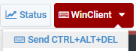

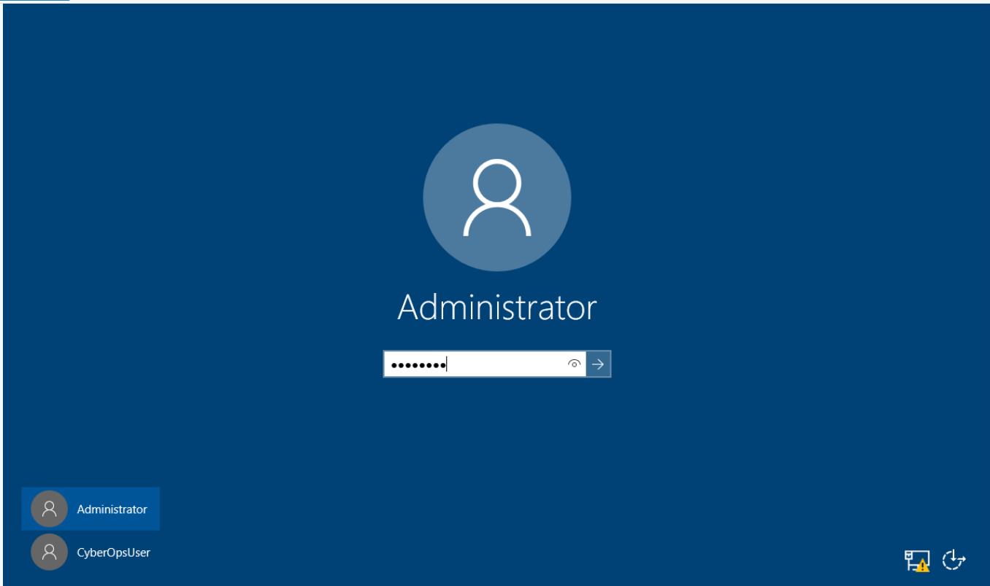

Accessing the VM on netlab.

#### Step 2

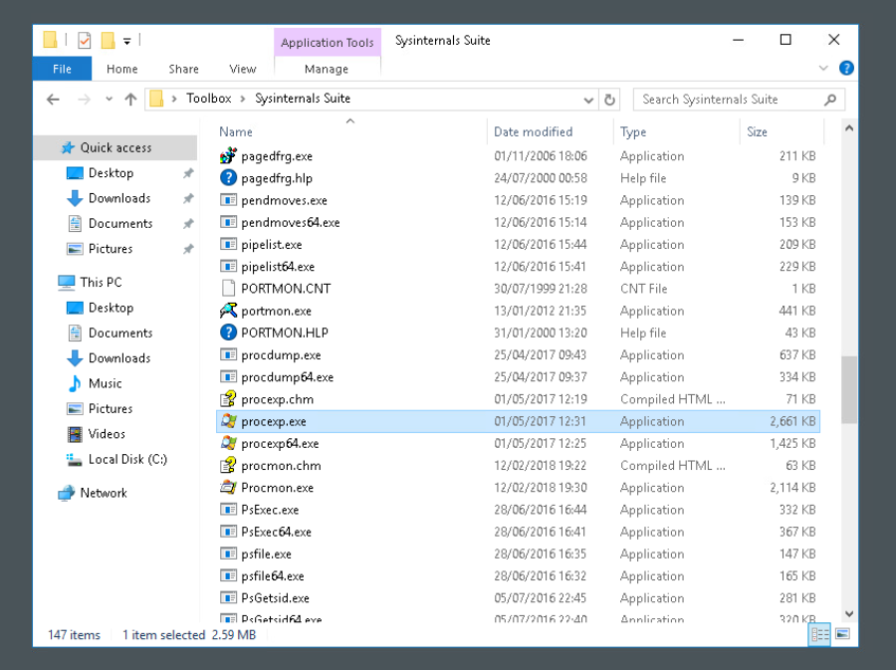Finding and locating the **Sysinternals Suite** folder on the desktop and locating the **procexp.exe** inside of the folder and starting it, then accepting the licence agreement to be able to use it.

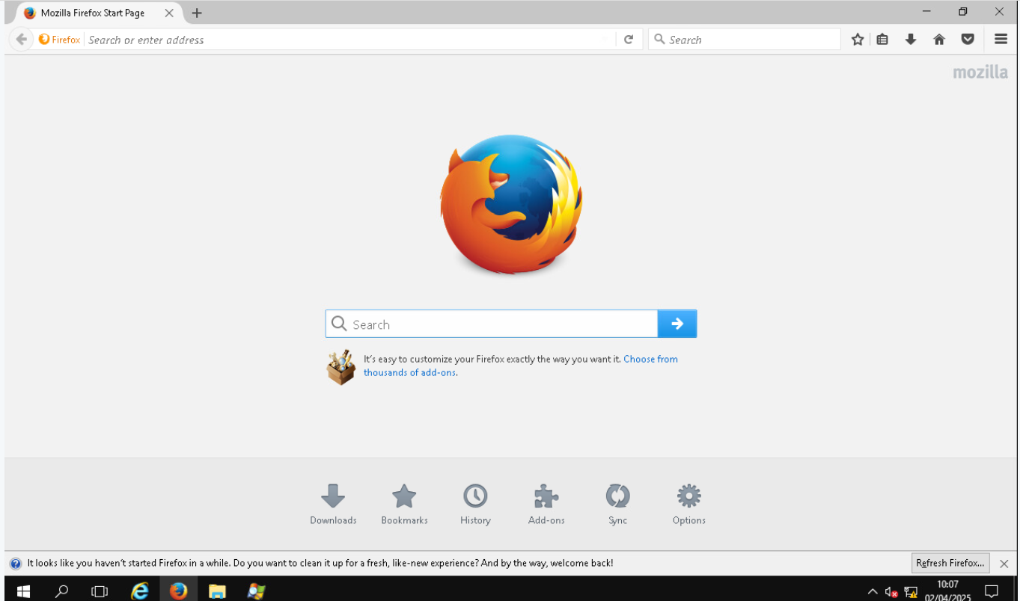Opening **Firefox** browser to be used in this task.

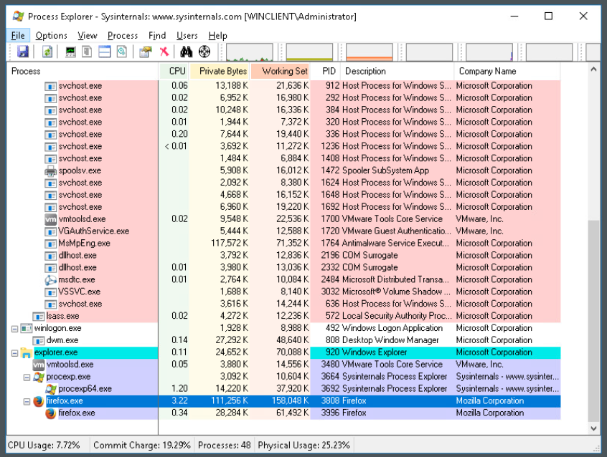Using the **Find Window’s Processes** (inside process explorer) by drag and dropping it onto the **Firefox** icon in the taskbar, it will locate the process inside of the process list

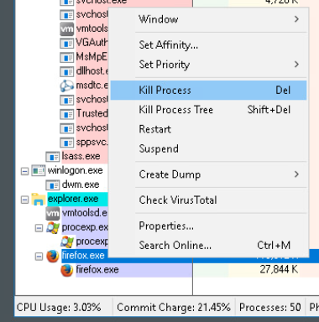

Right clicking the **firefox.exe** process will open a menu where the process can be terminated.

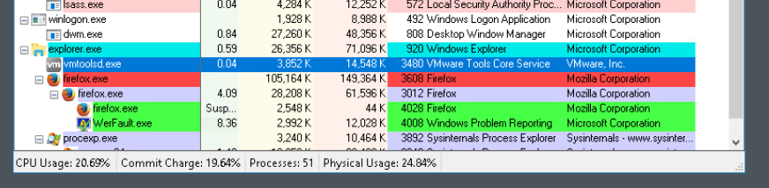After killing the process, the executable gets suspended, progressively stops using processing power (CPU usage as an example) and eventually turns red before disappearing from the process list.

#### Step 3

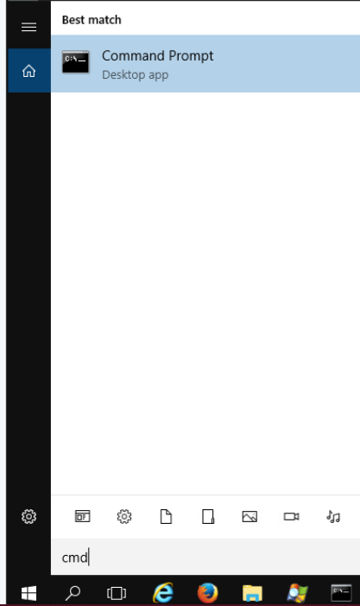

Opening **Command Prompt** application from search bar.

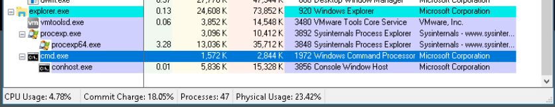

Using the **Find Window’s Processes** (inside process explorer) by drag and dropping it onto the **Command Prompt** icon in the taskbar, it will locate the process inside of the process list

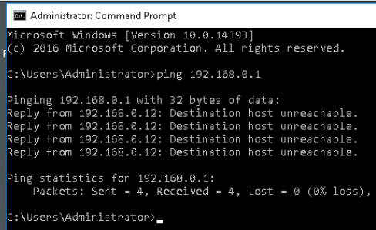

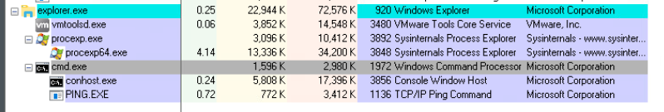

After typing the **ping** command with an appropriate IP address (in this case its **192.168.0.**1) in **cmd** your device will send a total of 4 packets to the desired IP address and will give a breakdown of how many packets were sent, received and lost. Additonally when executing the **ping** command, in the **Process Explorer** a child process will appear called **PING.EXE**.

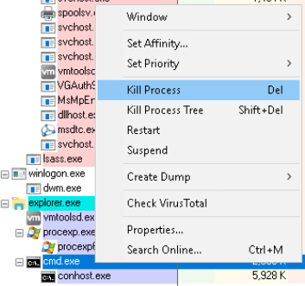

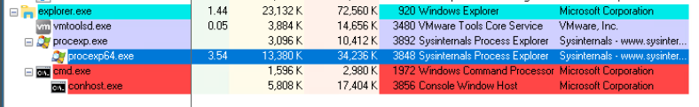After killing the process, the executable progressively stops using processing power (CPU usage as an example) and eventually turns red before disappearing from the process list as it has been terminated.

### Part 2

#### Step 1

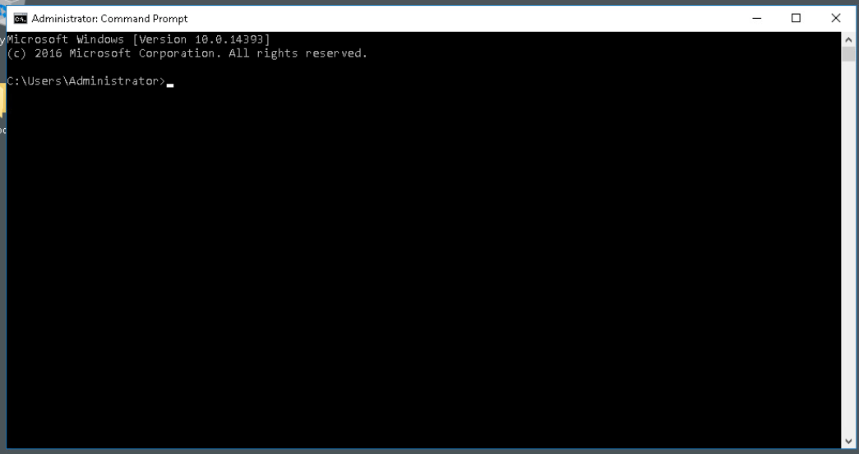Opening a fresh **Command Prompt**

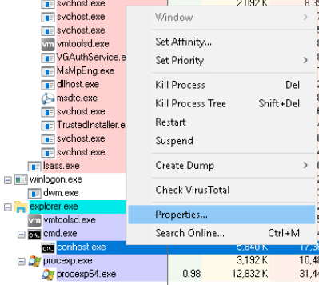

Tabbing back into the **Process Explorer**, finding the **cmd** process using the **Find Window’s Processes** tool and expanding it to be able to see **conhost.exe** process. After right clicking it and clicking on properties a property window will open.

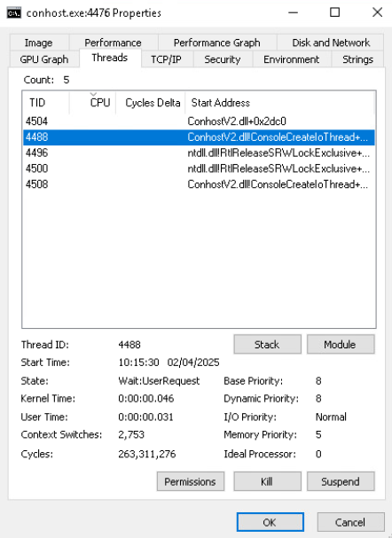

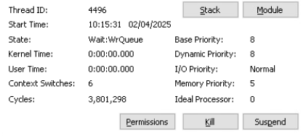

Inside the **Thread** tab each thread is selectable and once selected it will different information about each one (like memory priority and state)

#### Step 2

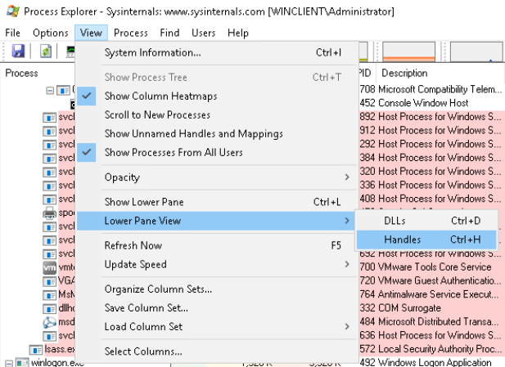

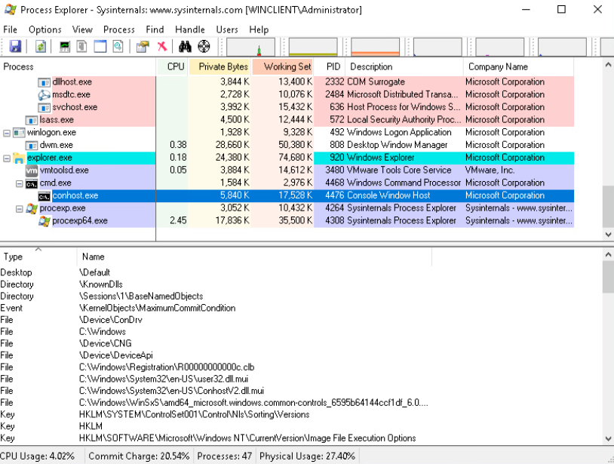Opening the **Handles** panel allows to see all associated files that are used on the process (in this example its for **cmd**).

### Part 3

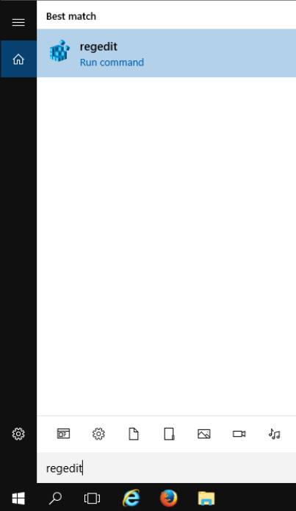

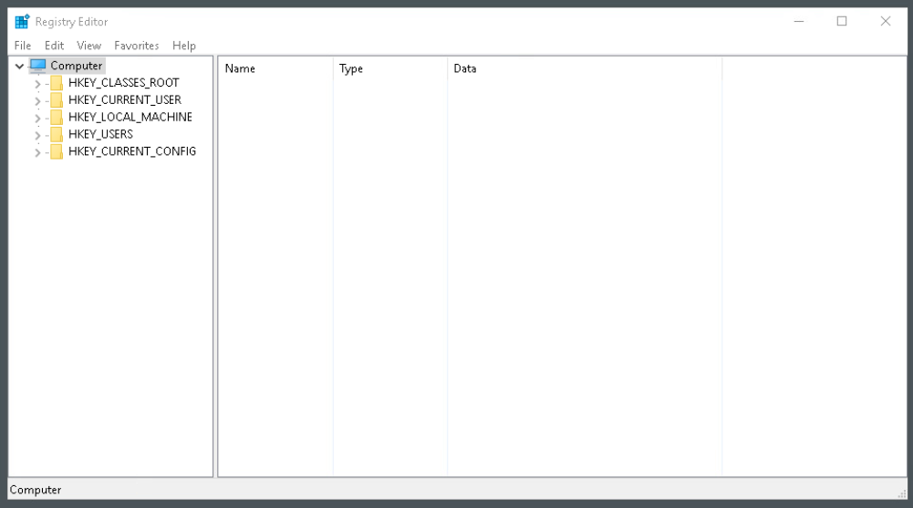

Opening **Registry Editor**

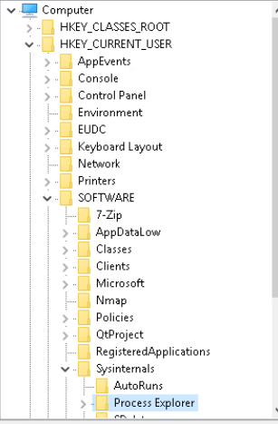

Following and expanding the hierarchy to locate the **Process Explorer’s** configuration

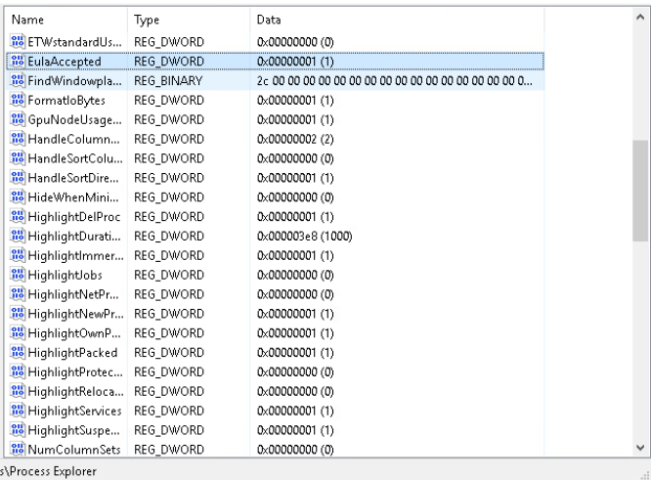

Highlighted is the **key** value behind the condition of "**EulaAccepted**”, and the value is 0x00000001 (1) - this prevents from the EULA window opening every time when opening the application

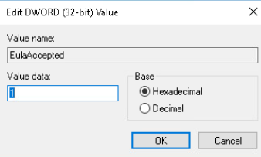

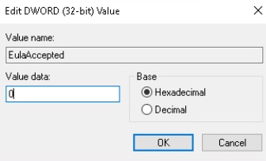

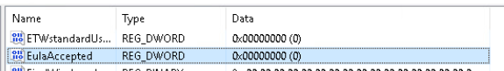

This key’s value can be edited, and for this task it will be changed to the value **0**, and saved by pressing **OK**. Once this is done the value of the **Data column** for this key will change to 0x00000000 (0), showing that the value has been changed.

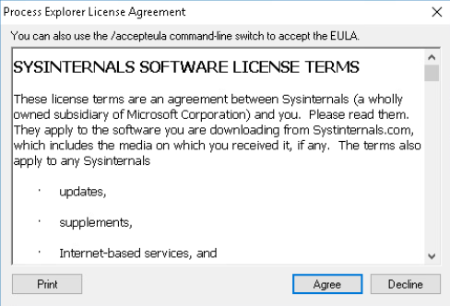

When opening the **Process Explorer** application again, the EULA window will open and will prompt the user to accept it before using the app.

## 7.3.10 Lab - Create User Accounts

### Part 1

#### Step 1



Accessing the VM on netlab

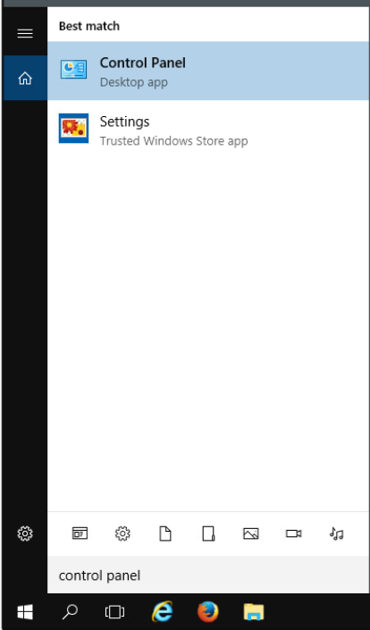

Opening **Control Panel**

#### Step 2

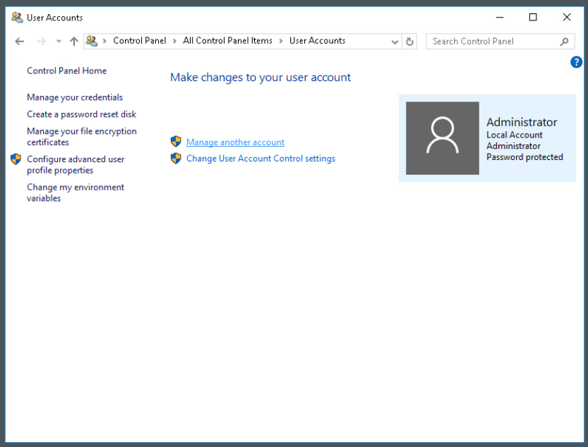

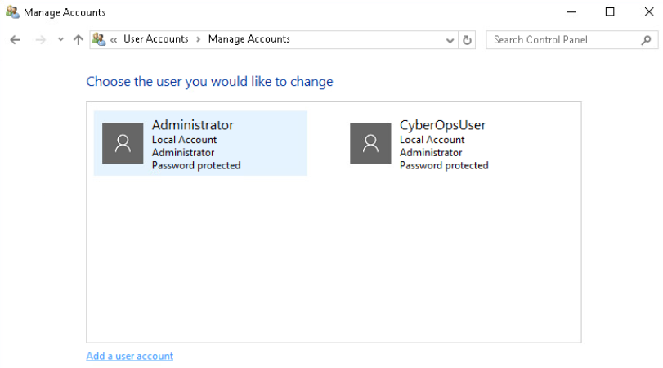

Accessing the **User Accounts** window and selecting “**Manage another account**” > “**Add a user account**”

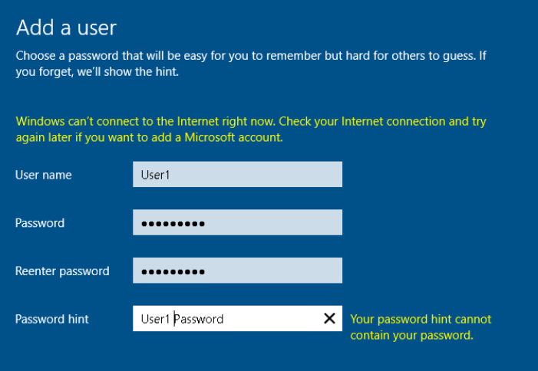

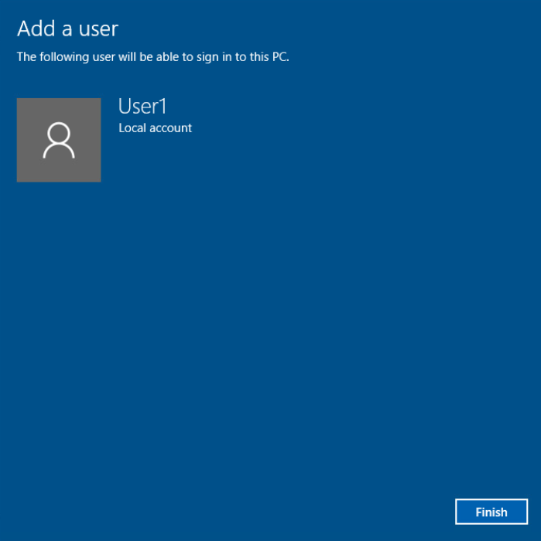

Creating a **new** user with mentioned parameters then selecting ”**Next**” > ”**Finish**”

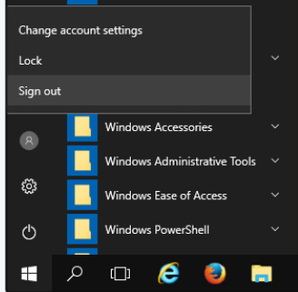

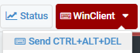

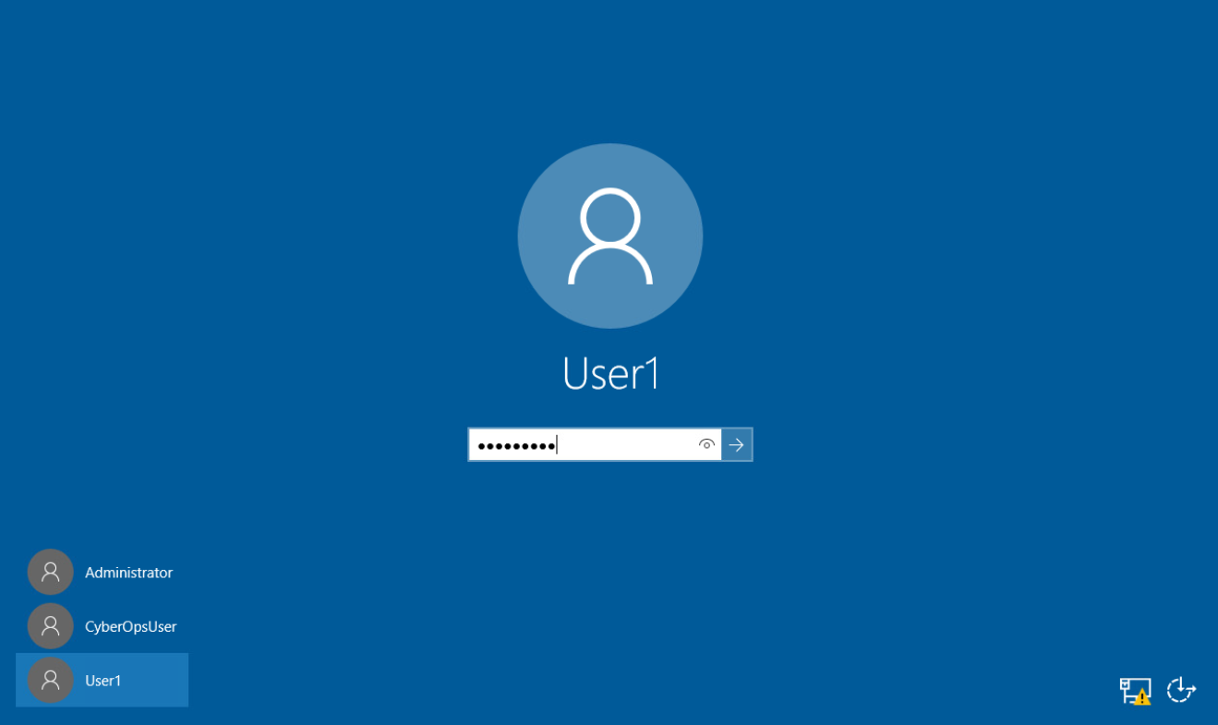Logging out of the current account and logging into the new **User1** account

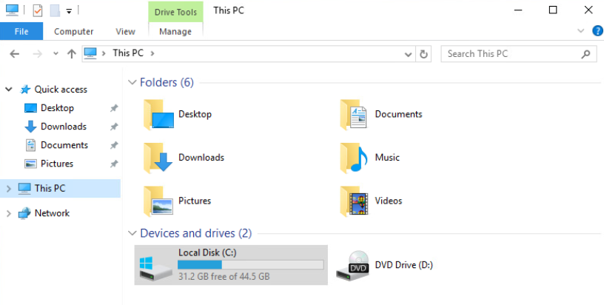

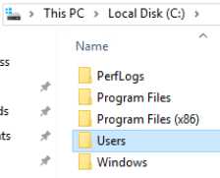

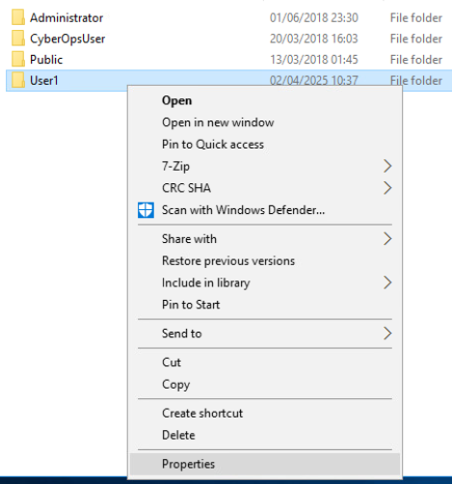

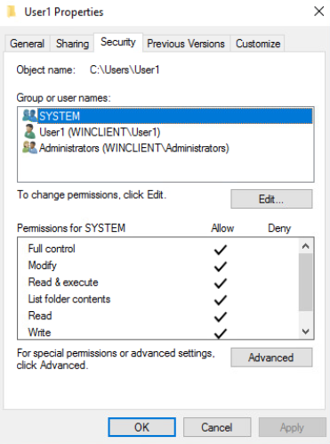

Navigating “**C:**” > “**Users**” > “**User1**” > “**Properties**” > “**Security**” will show the groups & users and the amount of access they have to the folder – in this case the groups **System** & **Administrators** have full access to the folder

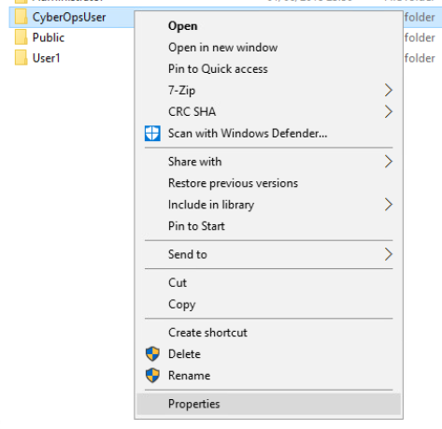

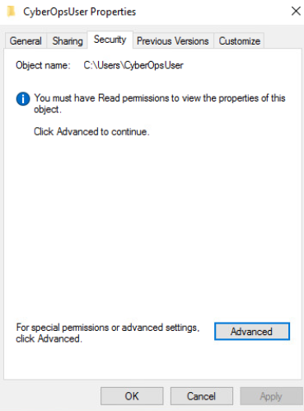

While logged in as **User1** and attempting to look at the **Security** tab of the **CyberOpsUser** folder, you will be denied access to view that data as you do not have the permission for that

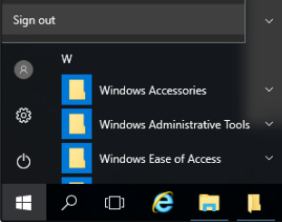

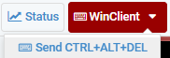

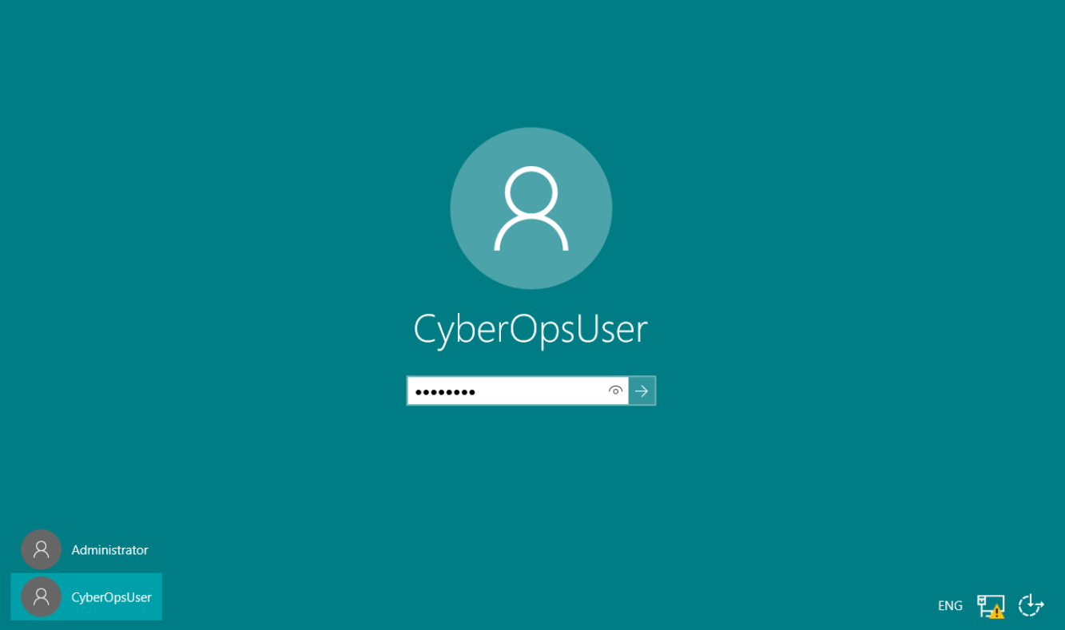Logging in as **CyberOpsUser**

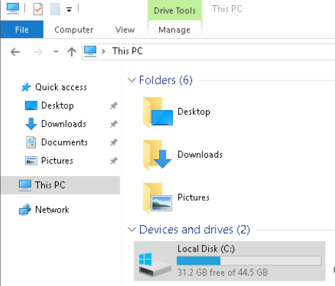

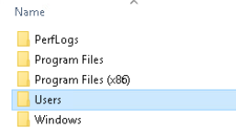

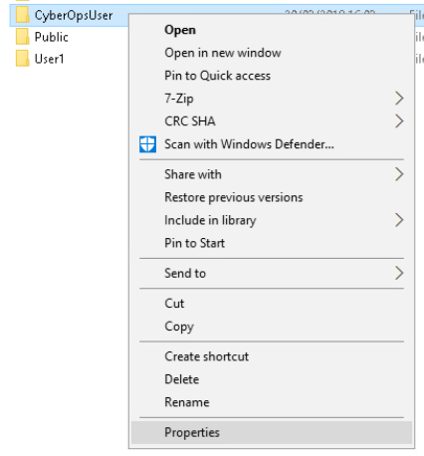

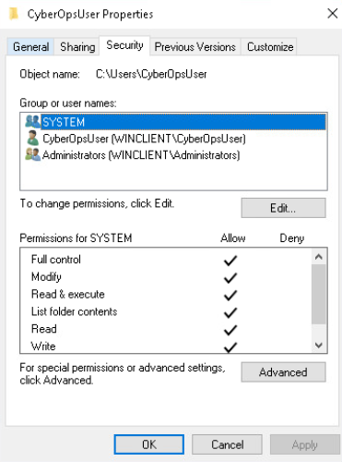

Navigating to the folder “**C:\Users**” and checking the **Security** tab of that folder will show that the system and administrator groups have full control over it

### Part 2

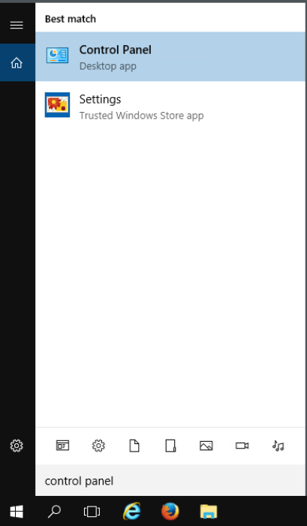

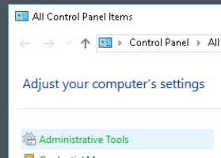

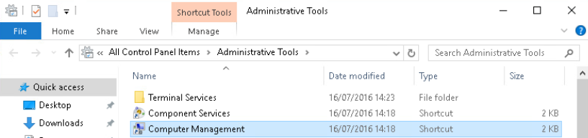Opening and navigating: ”**Control Panel**” > ”**Administrative Tools**” > ”**Computer Management**”

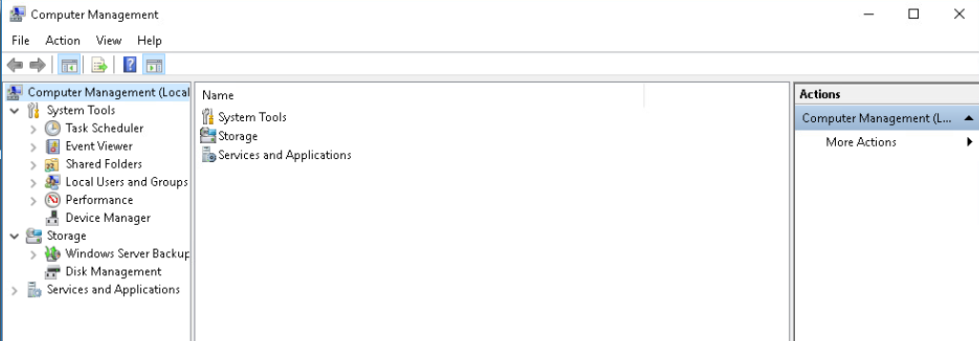

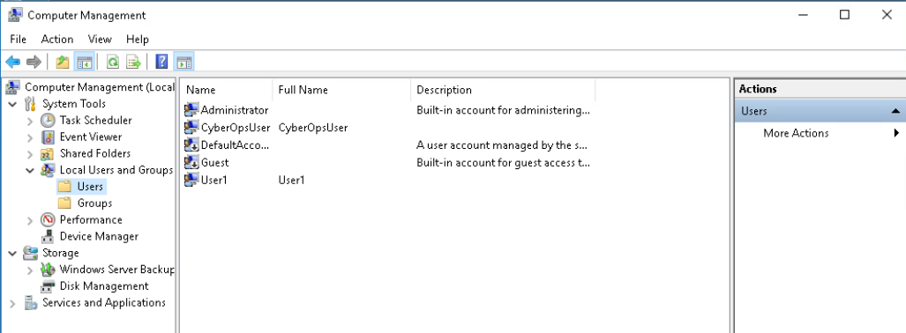

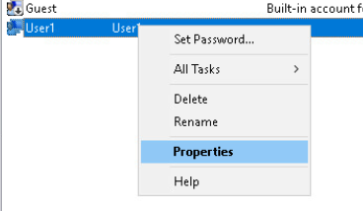

Navigating: ”**Local Users and Groups**” > ”**Users**” > “**Right click on User1**” > “**Properties**”

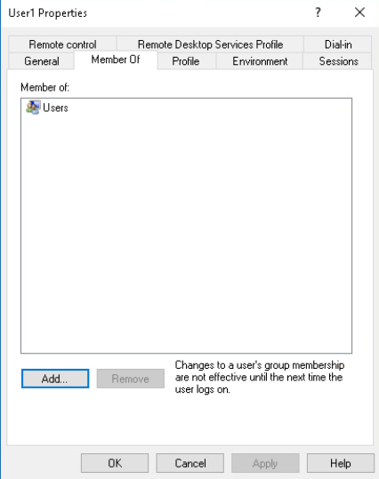

**User1** is a member of the group “**Users”**

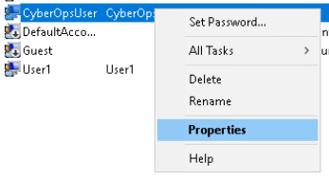

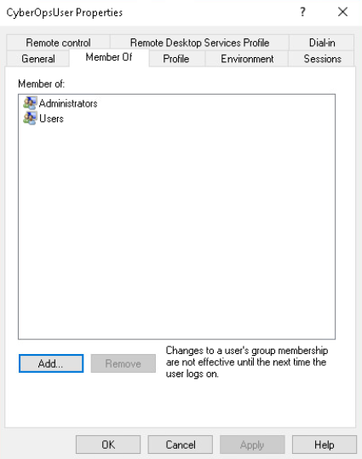

**CyberOpsUser** is a member of the groups “**Administrators**” and “**Users**”

### Part 3

#### Step 1

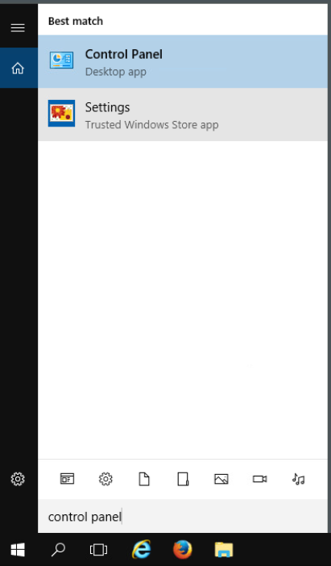

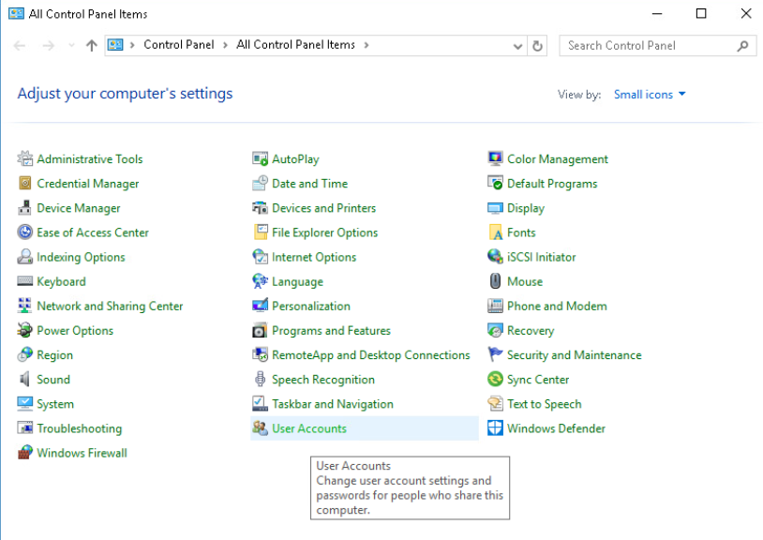

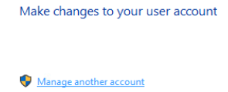

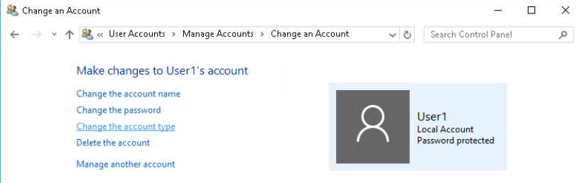Opening and navigating: ”**Control Panel**” > ”**User Accounts**” > ”**Manage another account**” > ”**Change the account type**”

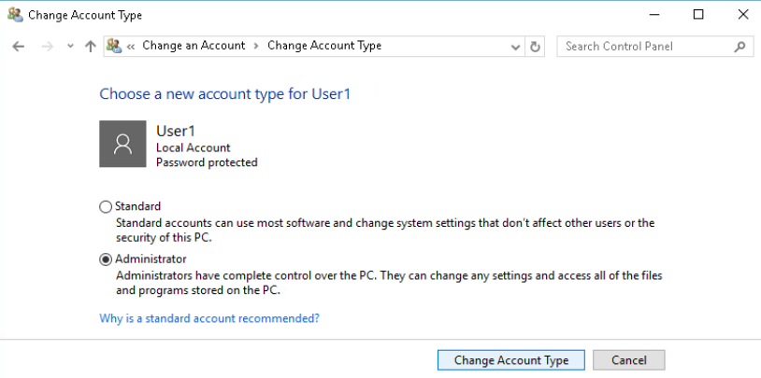Selecting the ”**Administrator**” radio button and pressing ”**Change Account Type**” button will give User1 **administrative rights**.

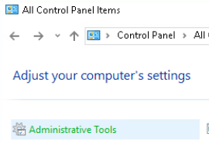

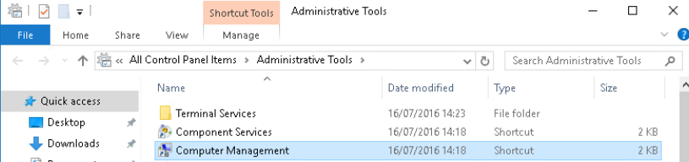

Navigating: ”**Control Panel**” > ”**Administrative Tools**” > ”**Computer Management**”

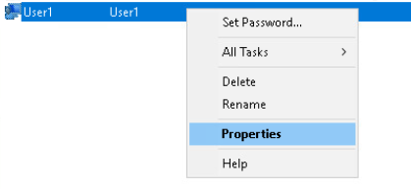

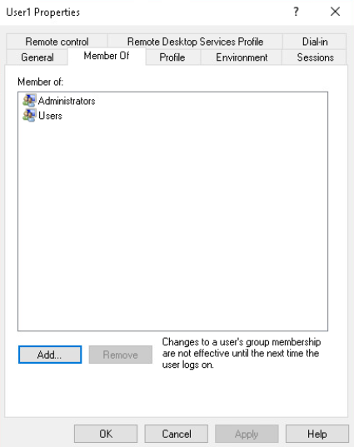

Navigating: “**Right click User1**” > “**Properties**” > “**Member Of**” will show that **User1** is a part of **Administrators** group

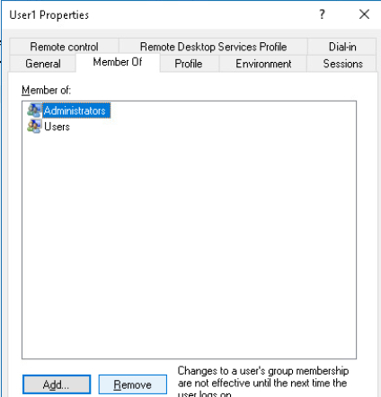

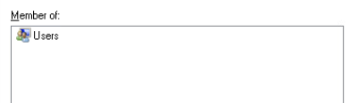

Navigating: “**Click Administrators**” > “**Remove**” > “**OK**” will remove **User1** from the group **Administrators**

#### Step 2

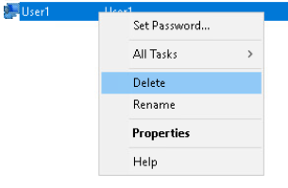

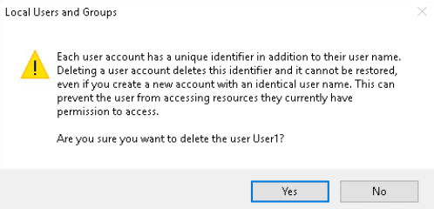

Navigate: “**Right click on User1**” > “**Delete**” > “**OK**” > “**Yes**” will delete the account from the device. Another way to delete a user account would be doing so via the Settings app

## 7.3.11 Lab - Using Windows PowerShell

### Part 1

#### Step 1



Accessing the VM on netlab

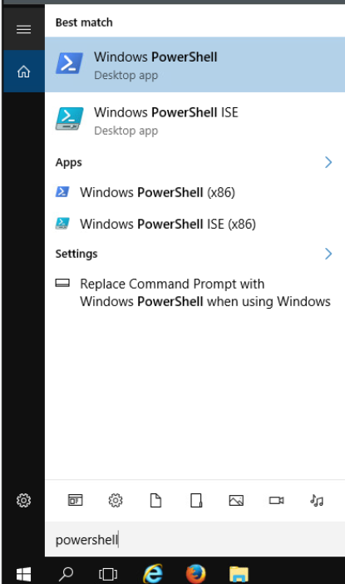

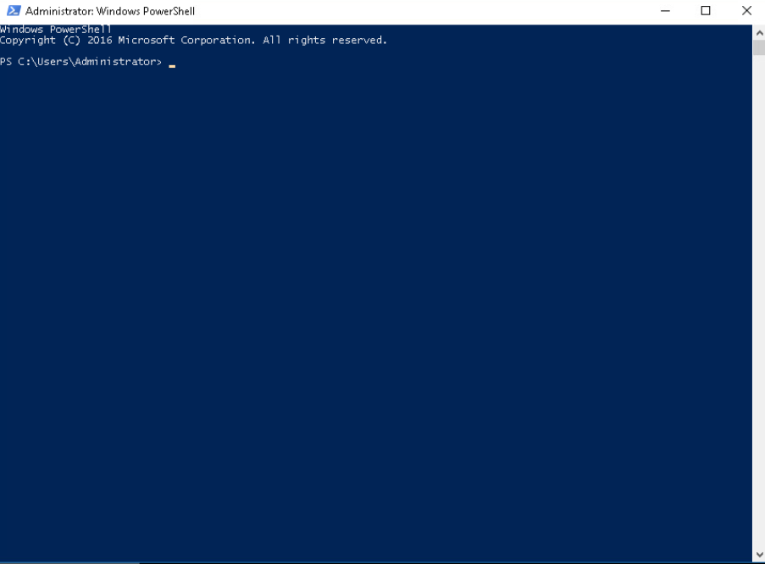

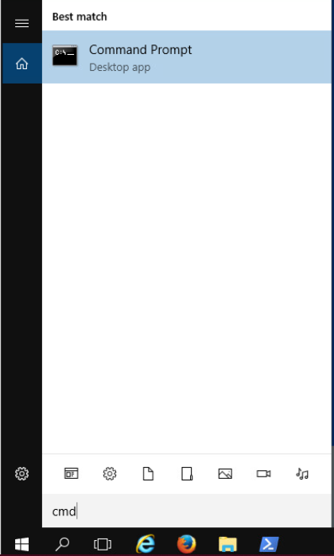

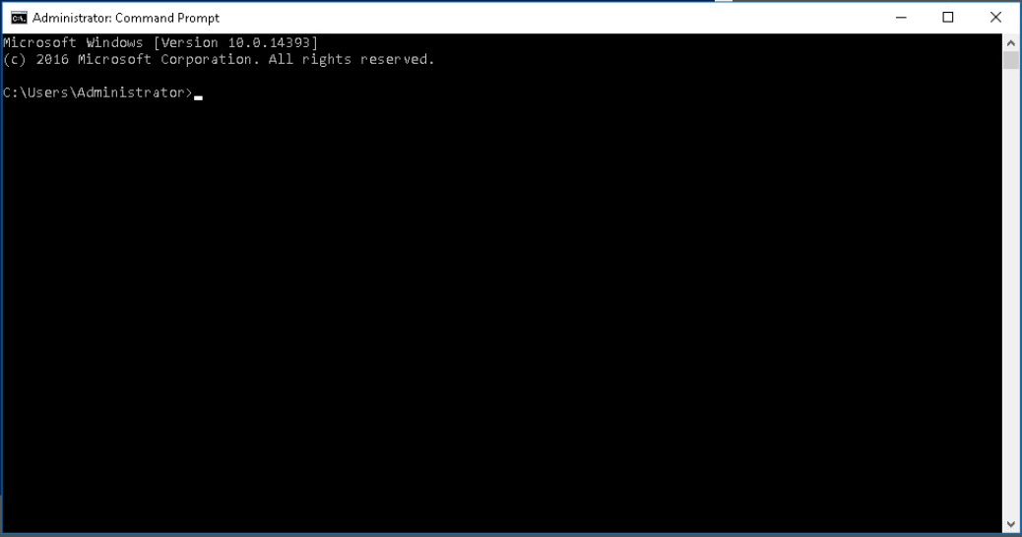Opening **Windows PowerShell** and **Command Prompt** via windows search bar

### Part 2

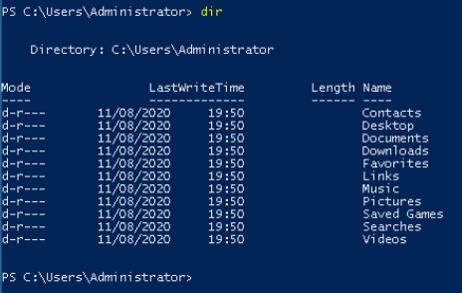

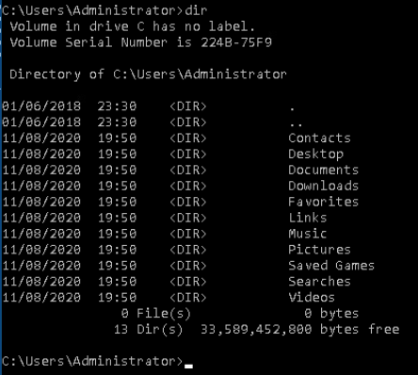

Using **dir** command on **PowerShell** provides a similar output to the output of **cmd** but with headers. But the **cmd** output contains data like the current directory “**.**” and the previous directory “**..**”, alongside the amount of data free on the drive.

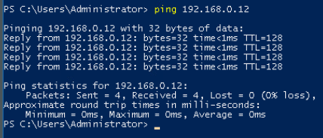

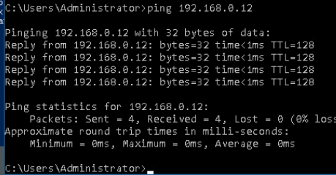

Using the **ping** command provides the same output both on **PowerShell** and **cmd**

### Part 3

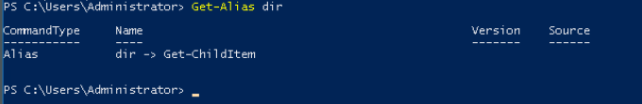

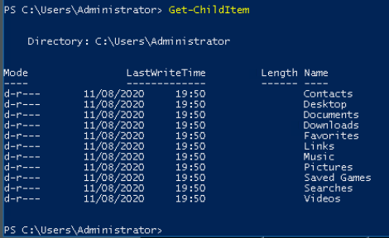

The PowerShell command equivalent of **dir** is **Get-ChildItem**

As shown when executing it, it gives the same output as the **dir** command

### Part 4

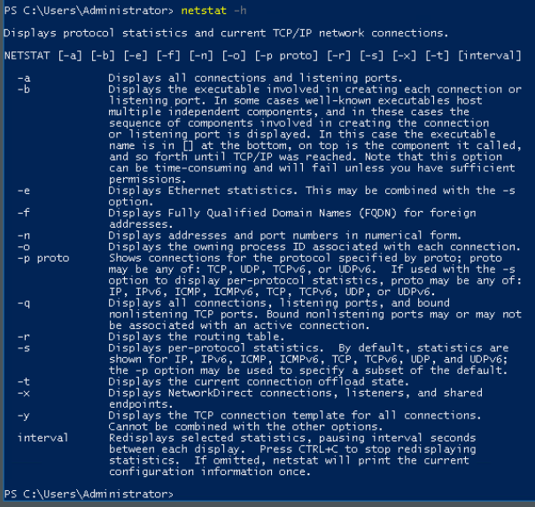

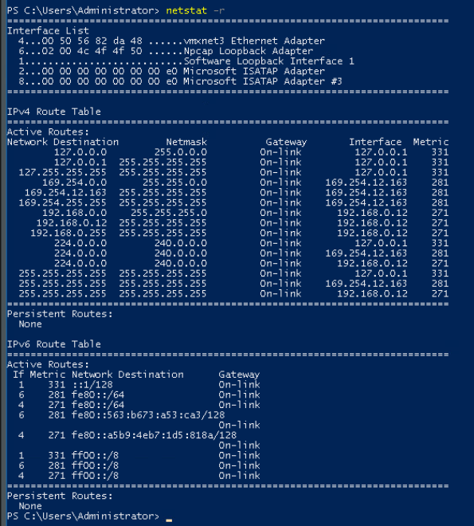

The IPv4 gateway would be 192.168.1.1

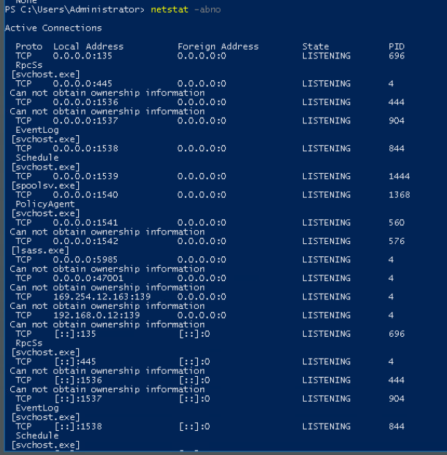

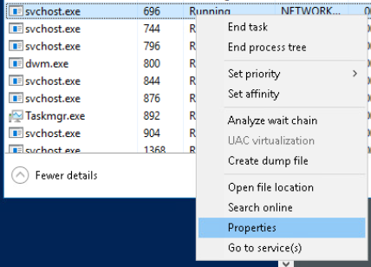

Navigating: “**Task Manager**” > “**Details**” > “**Click on PID**” and finding the PID value of 696 (for this task). Once found, Right click and open **Properties**.

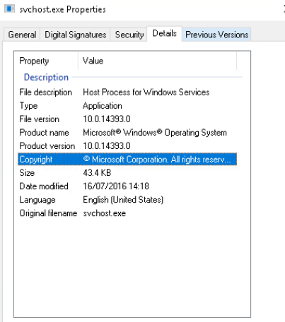

From the “**Details**” tab you can find details like size of the file, the type of file it is (in this case Application) and a description of the file

### Part 5

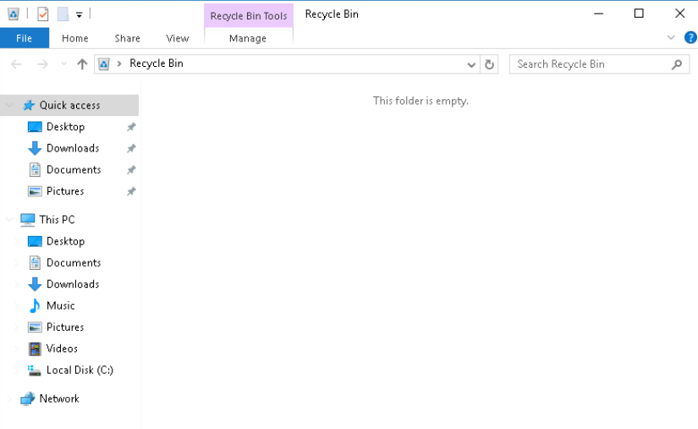

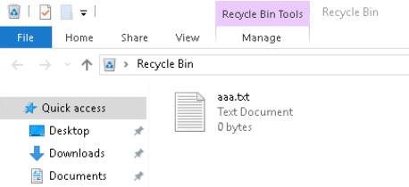

Opening the **Recycle Bin** from desktop and creating a dummy text file and dropping it inside the bin

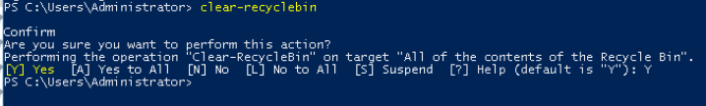

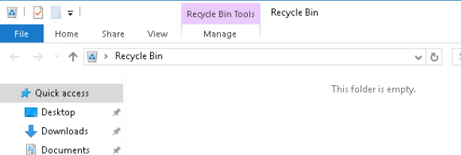

Entering “**clear-recyclebin**” into PowerShell and confirming the execution will clear the bin’s contents.

## 7.3.12 Lab - Windows Task Manager

### Part 1

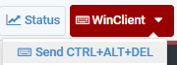

Accessing the VM on netlab

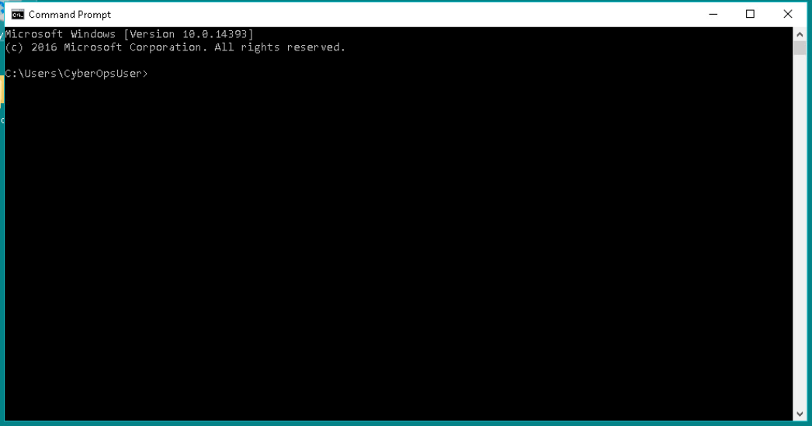

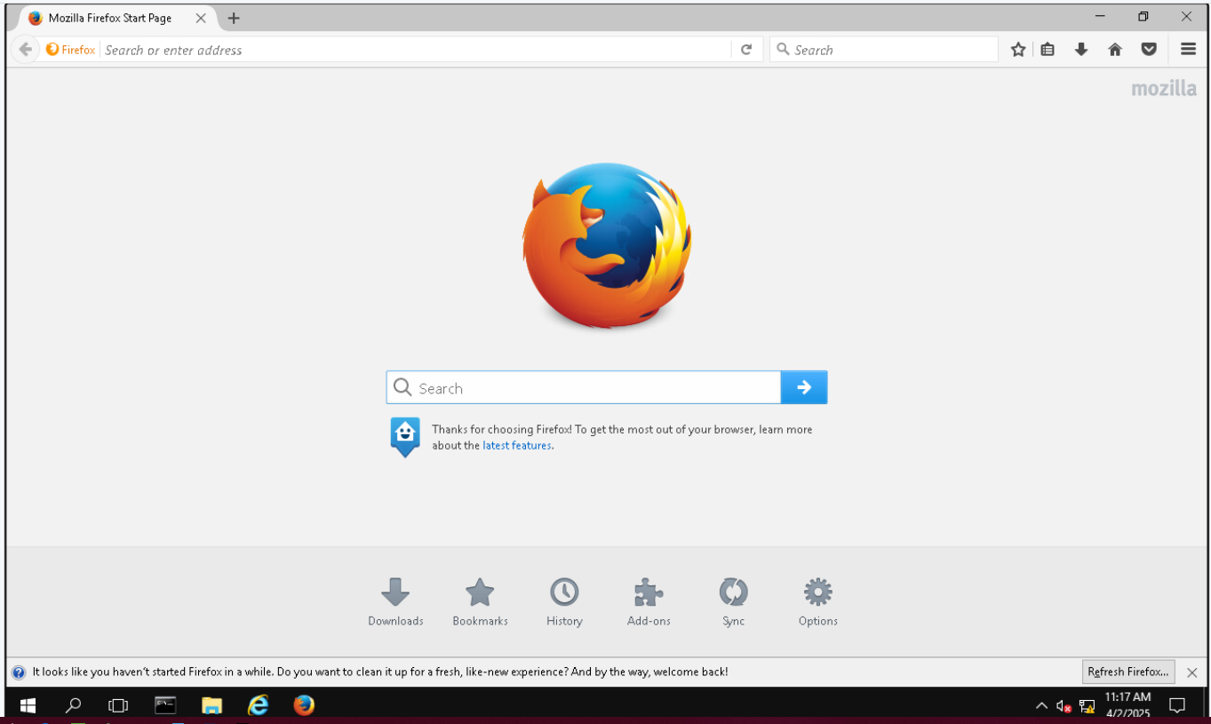

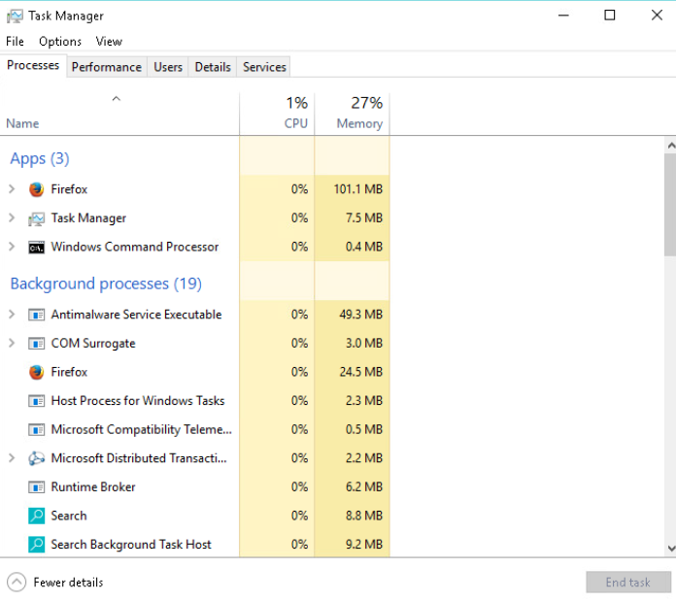Opening **Firefox**, **Command Prompt** and **Task Manager**

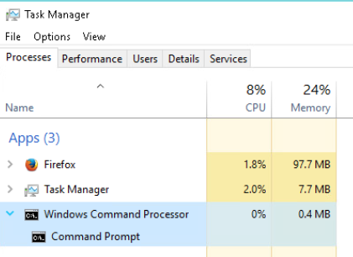

Locating the **Windows Command Processor** and expanding it (which contains **Command Prompt**)

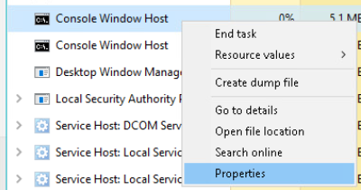

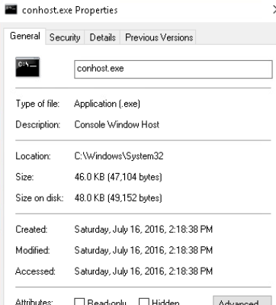

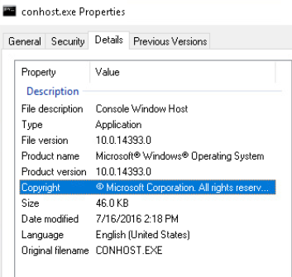

Locating **Console Window Host**,right clicking it and selecting properties will allow us to check the file name (which is found at the top-most entry field) and the location of the file – **C:\Windwos\System32**. The original file name of the file can be found in the **Details** tab.

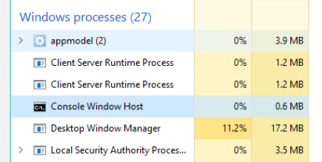

After closing the **Command Prompt** window, it will disappear from task manager and one of the **Console Window Host** processes will disappear, resulting in a slight decrease of CPU and memory usage

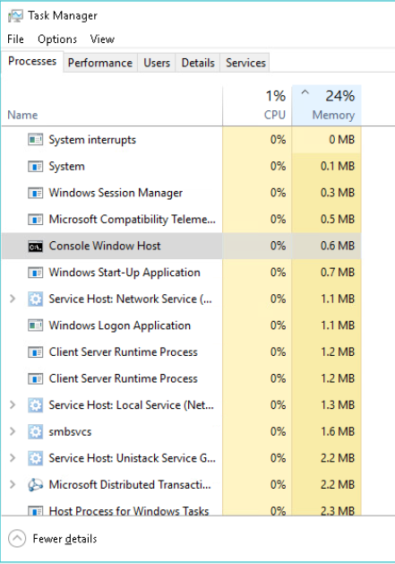

Clicking on the **Memory** heading will sort all the processes in an **Descending** order,after another click on the header will sort all the processes in a **Ascending** order.

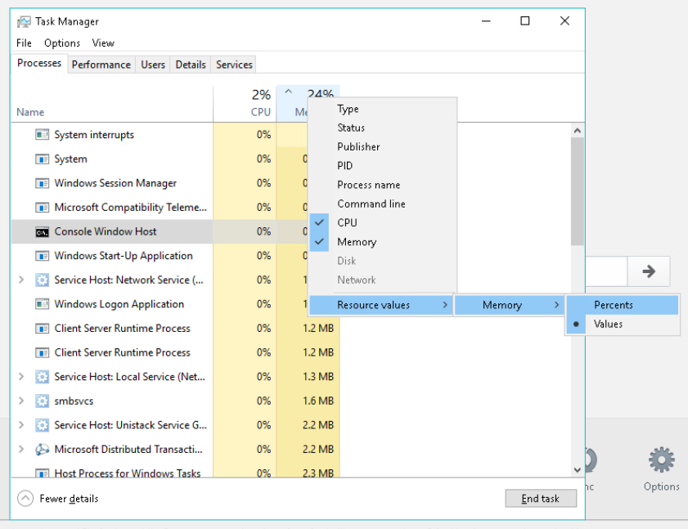

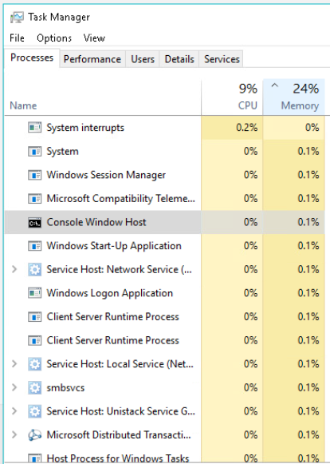

Changing the display of the resource values to **Percents** will show the percentage value of the process out of the total (in this case) memory used (in descending order)

This way the user is able to locate any potentially malicious processes that are using an unusual amount of processing power, be it **CPU**, **Memory** or **Disk Usage**

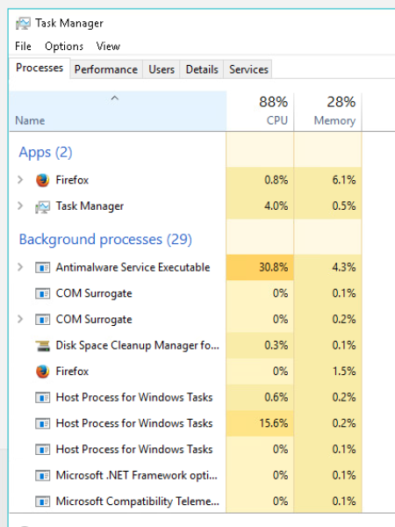

Clicking on the **Name** header will sort the processes into the 3 categories **Apps**, **Background Processes**, and **Windows Processes –** in descending alphabetical order

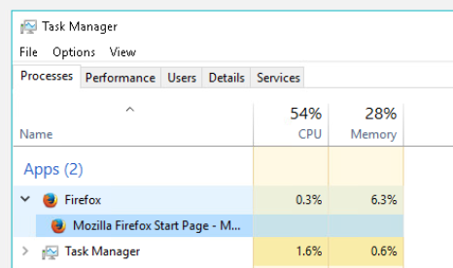

Double clicking the browser will expand the application and show all different processes that the application is using, and allow you to pinpoint which process is using what specific amount of resources

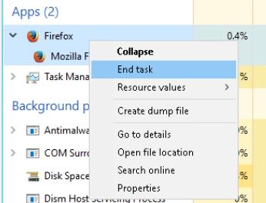

Ending the task on the browser will close the application

### Part 2

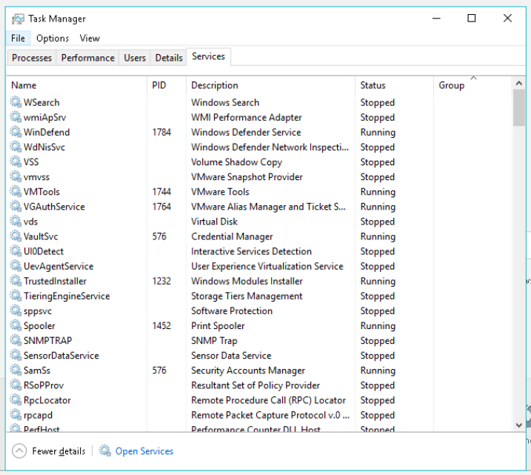

The **Services** tab shows all the windows services that run in the background. Each service has a description that comes with it, a PID (if the service is running) and the status of each service.

### Part 3

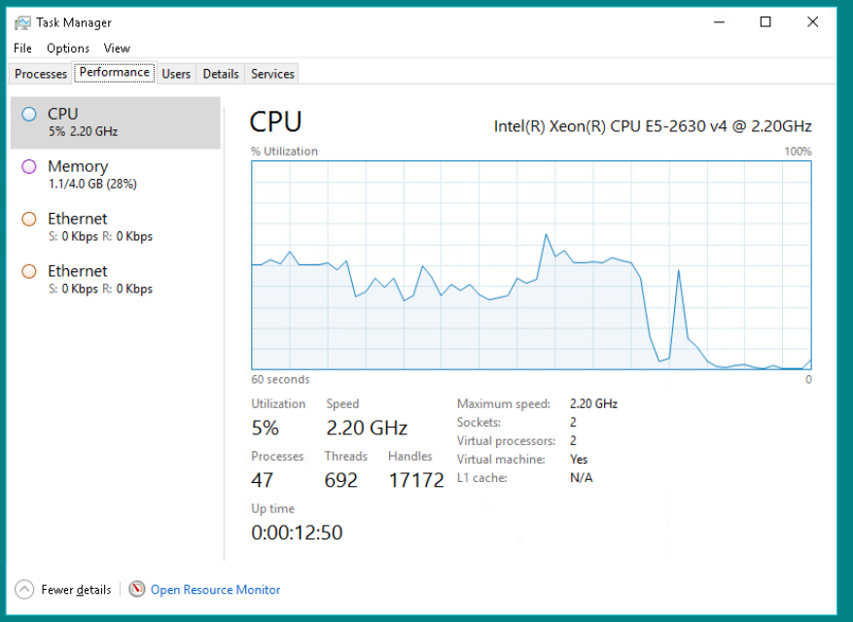

There are currently 692 in use and a total of 104 processes running

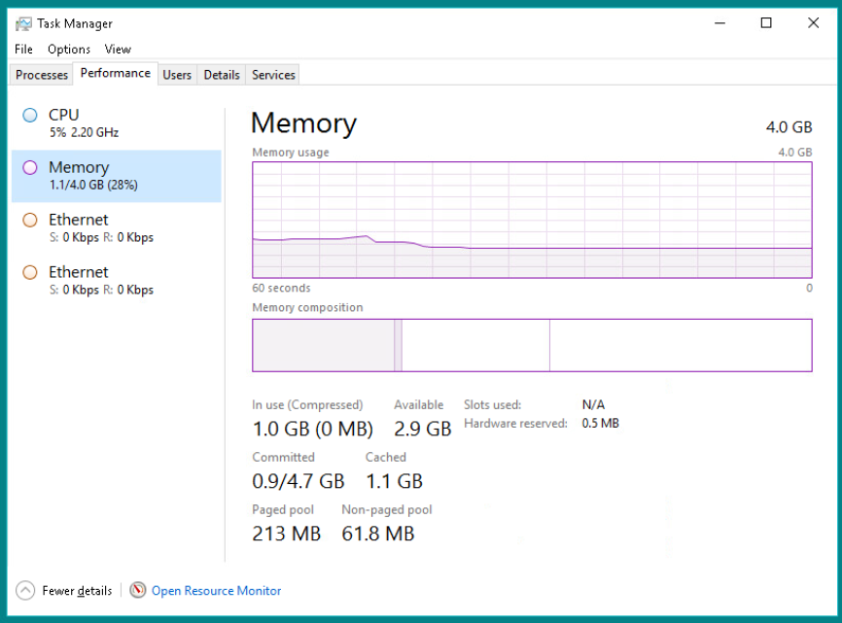

There is a total of 4.0 GB physical memory, 2.9 GB available physical memory and 1.0 GB memory in use.

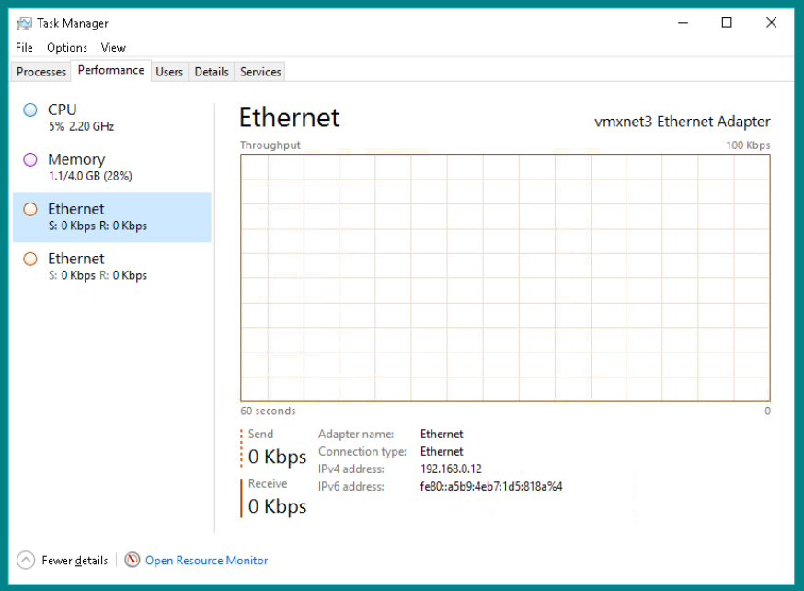

The link speed is shown by the **Receive** section of ethernet section, in this instance its 0kbps as its the VM used on Netlab, and the IPv4 address of the VM is 192.168.0.12

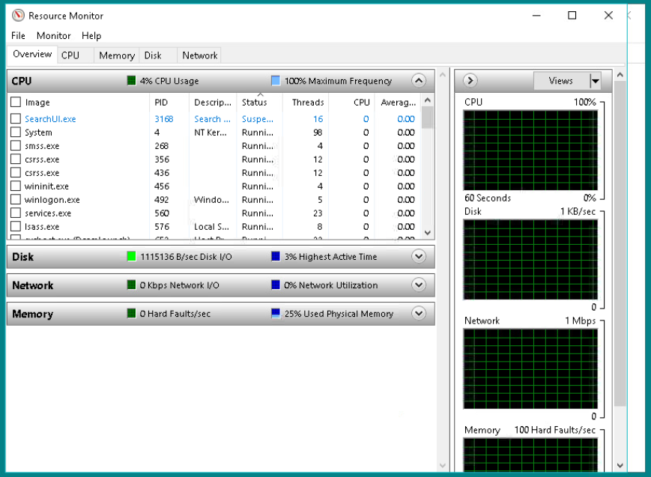

# Module 8: Linux Labs

## 8.2.6 Lab – Working with Text Files in the CLI

### Part 1

#### Step 1

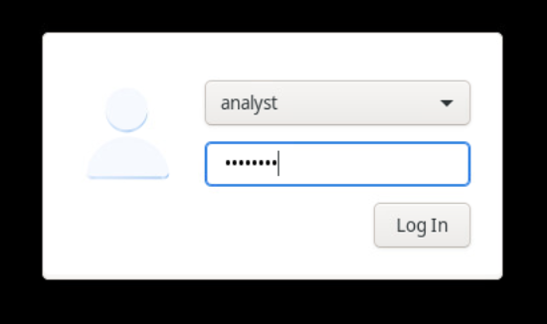

Logging into the VM

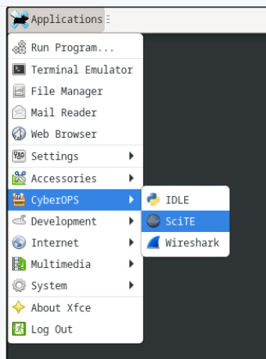

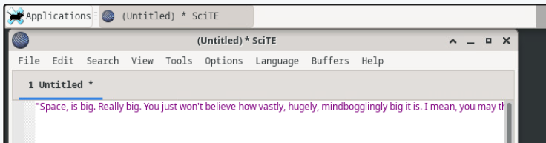Opening the **SciTE** text editor and entering some text inside it

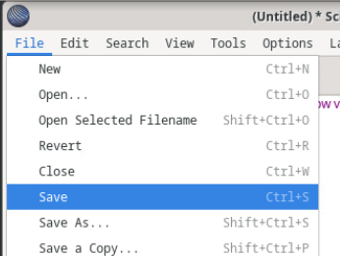

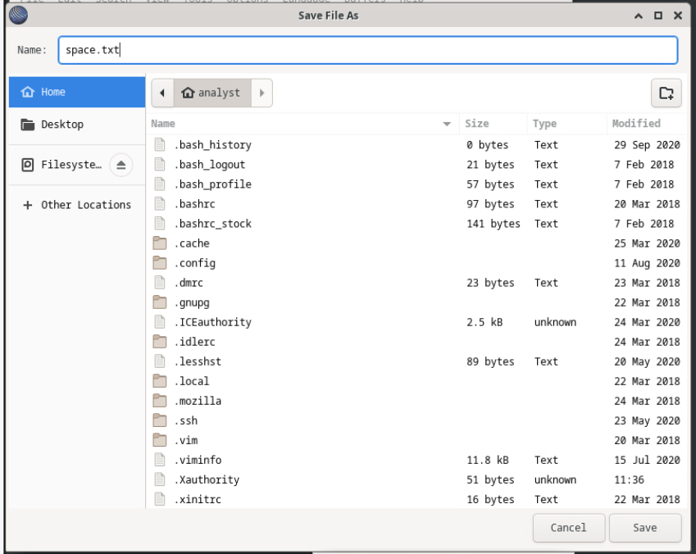Saving the text file in the **home directory**

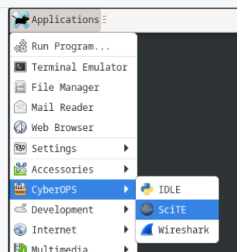

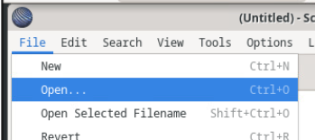

Re-opening the text editor and locating the text file

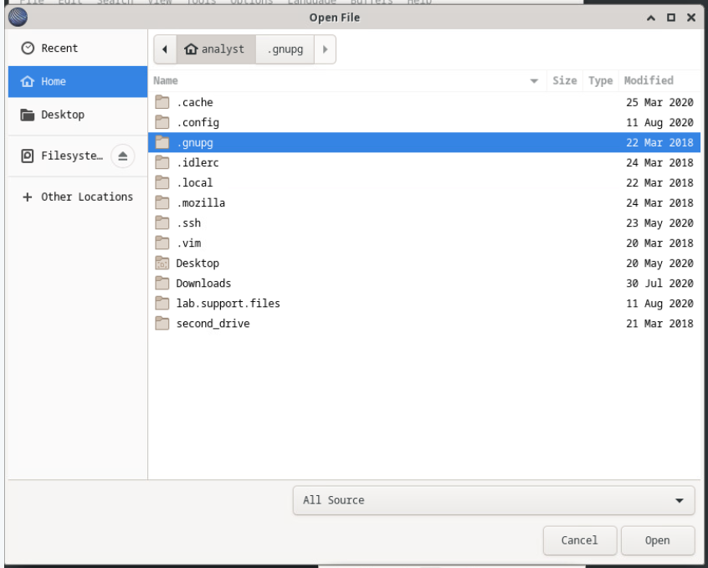

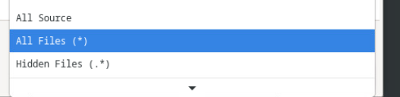

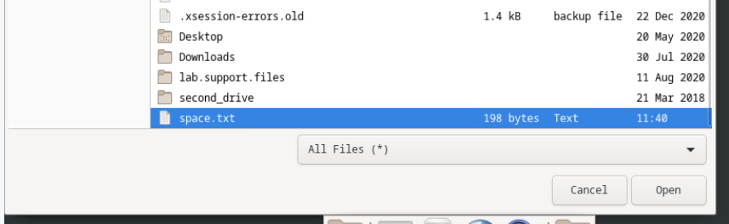

The text file is hidden due to the “**.txt**” file extension not classified as a “known extension” to the editor, as such you need to change visibility to **All Files (*)**

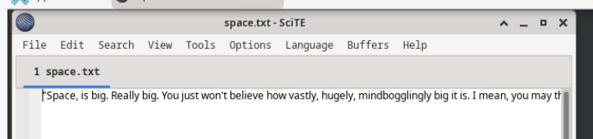

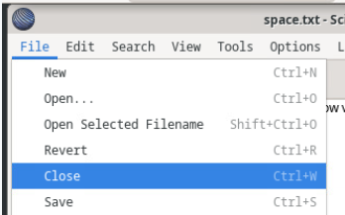

Closing the .txt file

### Step 2

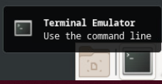

Opening terminal

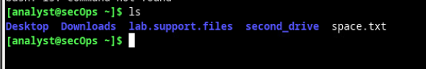

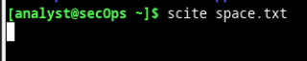

Opening the .txt file and loading it using the command “**scite**”

The next prompt doesn't show as the terminal currently has a process running – you need to interrupt the process to be able to enter another prompt

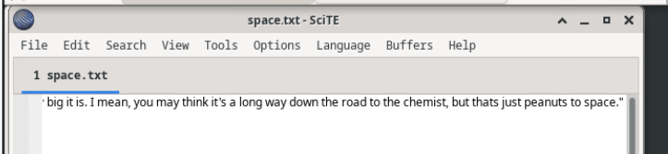

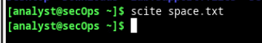

### Part 2

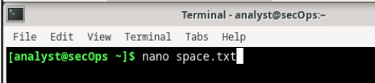

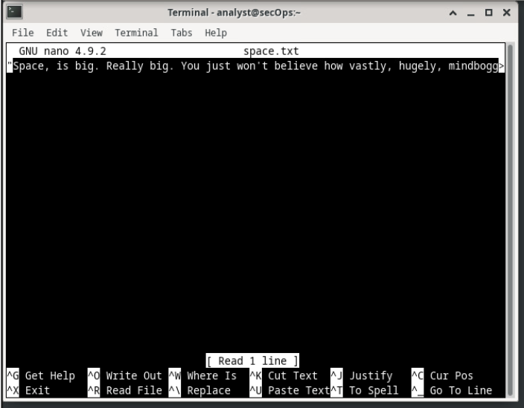Using the command **nano** followed by the **.txt** file, will display the contents of the file. The UI shows that there is more to a line using the **>** symbol found near the end of the border.

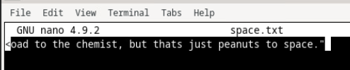

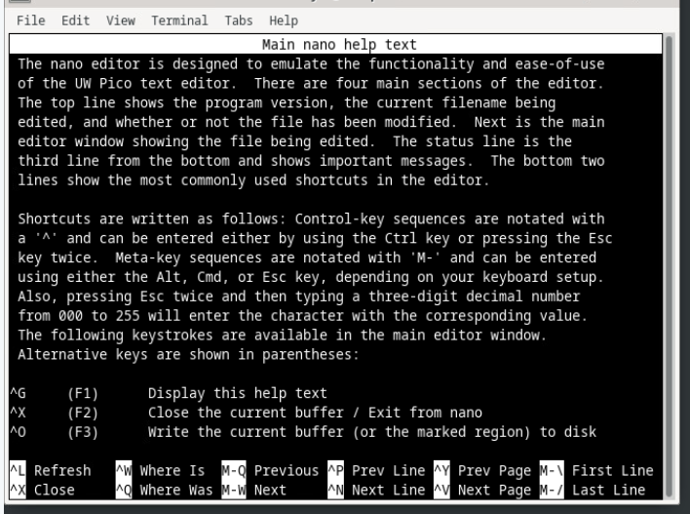

Accessing the help screen of **nano** is done by pressing **CTRL + G**.

### Part 3

#### Step 1

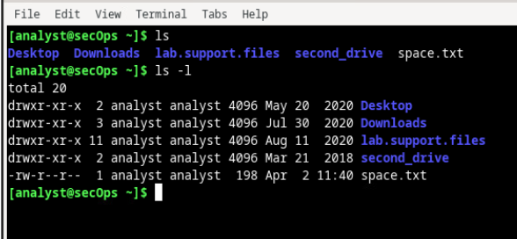

Using the **ls -l** command to list all the files in the home directory

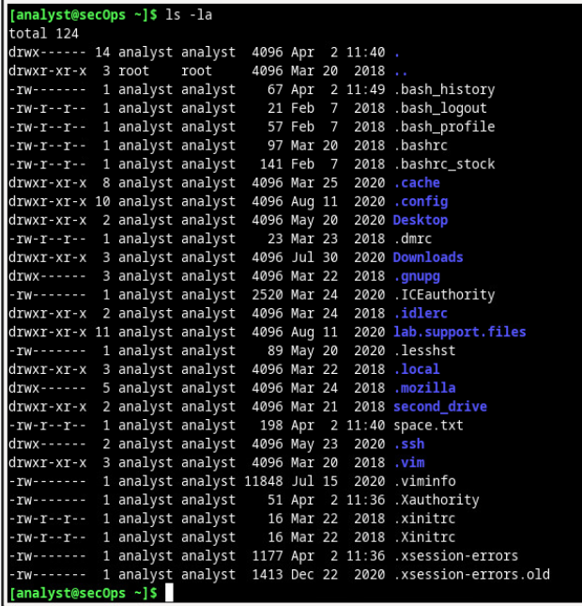

Using the **ls –la** to show all the files in the home directory (including the hidden files)

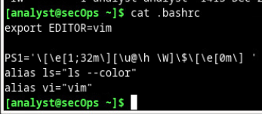

Using the **cat** command to display the contents of the **.bashrc** file

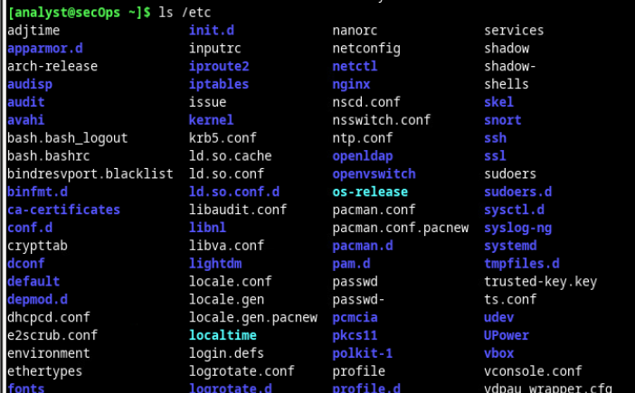

Using the **ls** command to show the contents of the **/etc** directory

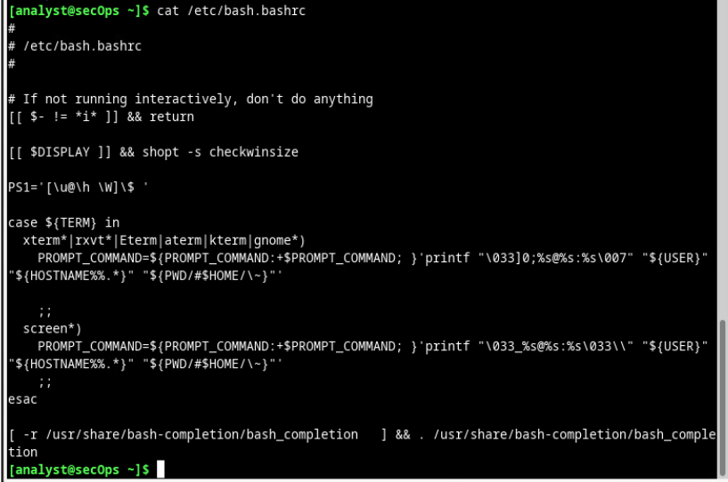

Using the **cat** command to display the **bash.bashrc** file (from the **/etc** directory)

#### Step 2

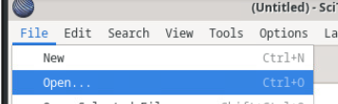

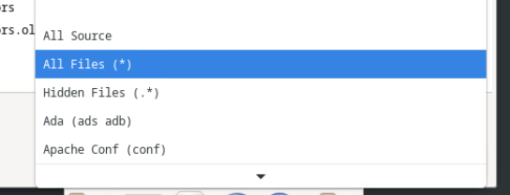

Selecting **All Files (*)** to see the hidden files

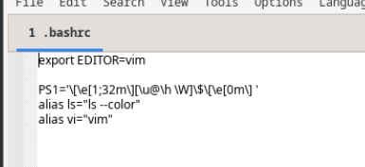

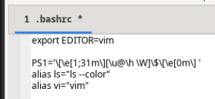

Opening the **.bashrc** file and changing the colour code from 32 (green) to 31 (red)

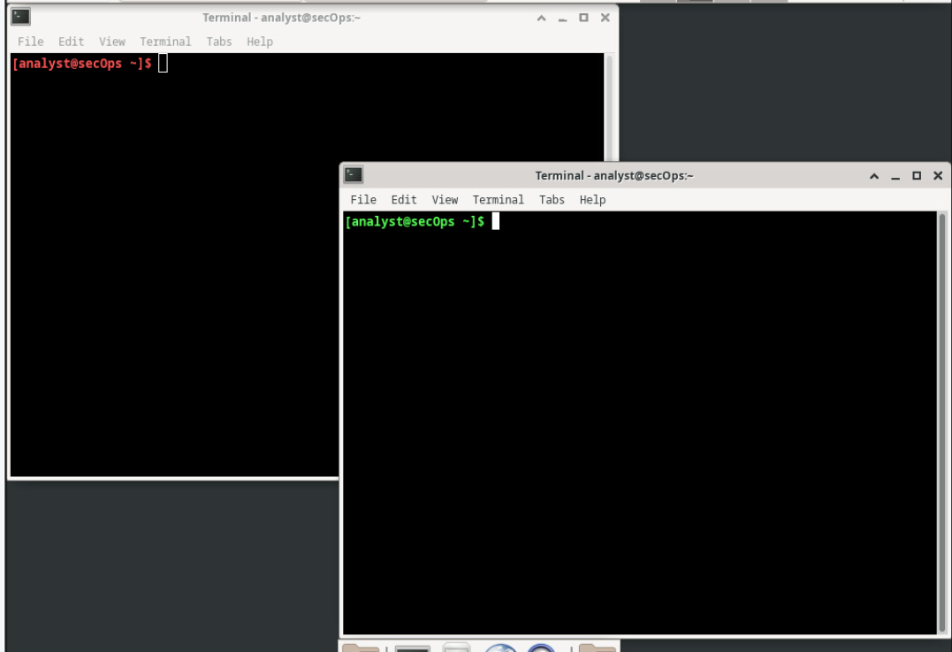

After saving the file the terminal that is already open does not change colour to red, but if a new one is open then the colour of the new terminal is changed to red

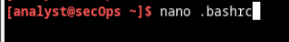

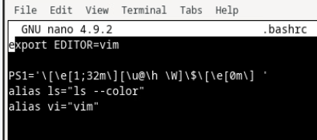

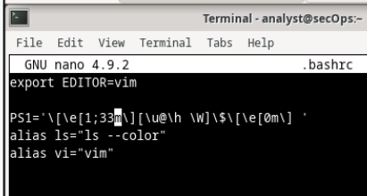

Opening the **.bashrc** file using the **nano** command, and changing the colour code to 33 (yellow)

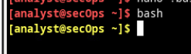

Using the command **bash** will reload the terminal and the colour of the text in the terminal will update.

#### Step 3



Using the **sudo nano -l** command to access the configuration file in the **/etc/nginx** directory

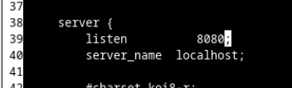

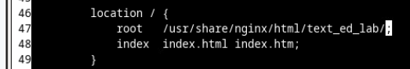

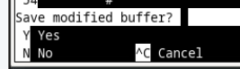

Changing the port number from **81** to **8080** and changing the root path from **/usr/share/nginx/html/** to **/usr/share/nginx/text_ed_lab/**



Executing the new configuration

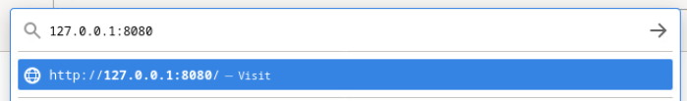Accessing the website on the new port

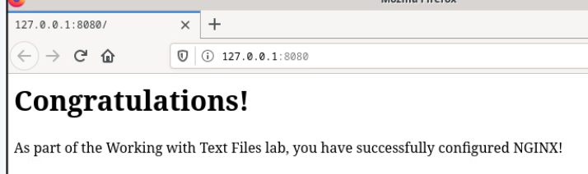

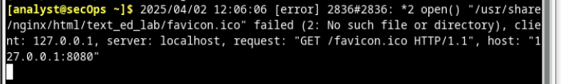

The error message is coming up due to a missing file “**favicon.ico**"

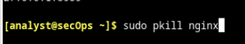

Using the **sudo pkill nginx** will terminate the website

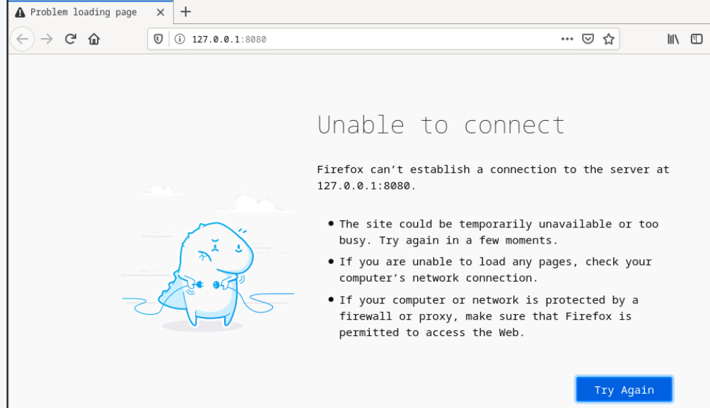

## 8.2.7 Lab – Getting Familiar with the Linux Shell

### Part 1

#### Step 1



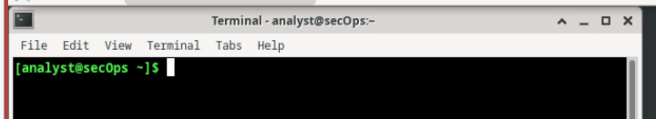

Logging into the VM on netlab and opening terminal

#### Step 2

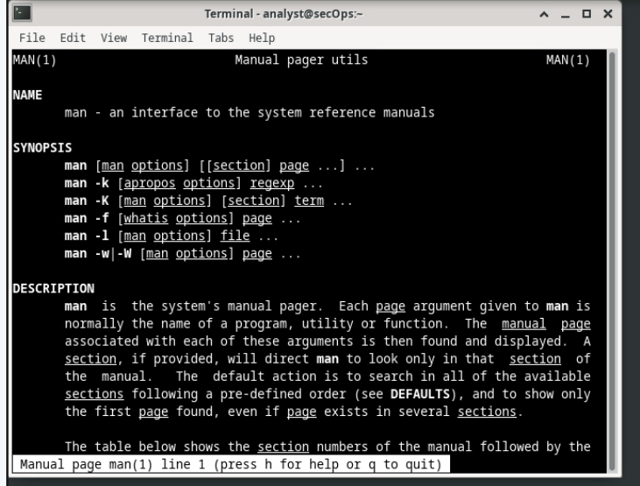

Opening the man (manual) page using **man man** in terminal

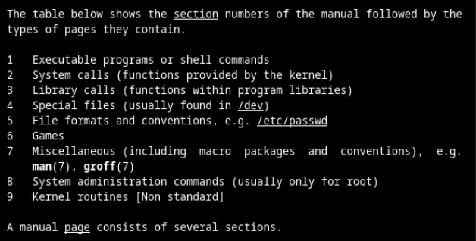

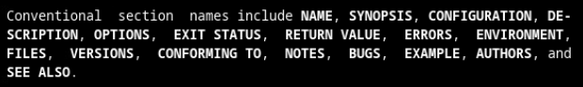

Some of the sections on this page are **Library calls**, **Special Files** and **Games**

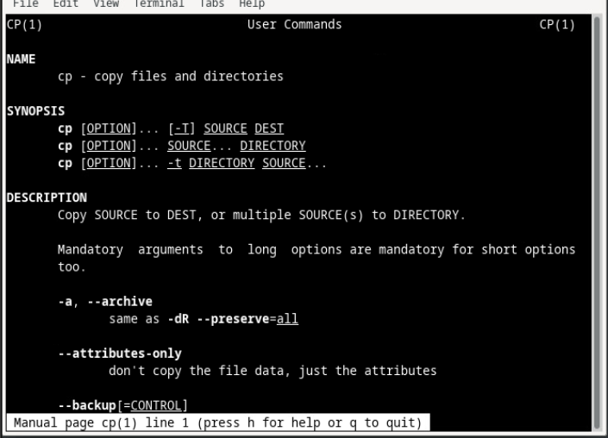

The **cp** command allows the user to copy files and directories

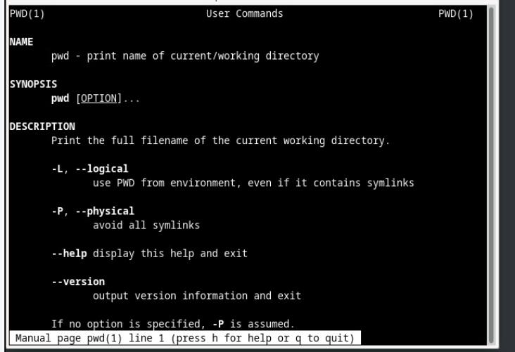

The command to learn about the **cp** command would be **man cp**

#### Step 3

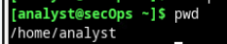

Using the **pwd** command the current directory is **/home/analyst**

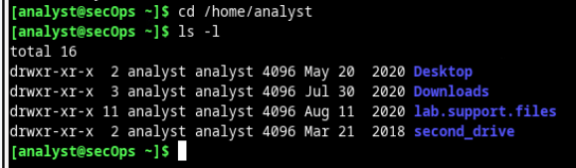

Using **ls –l** showing all file sin directory

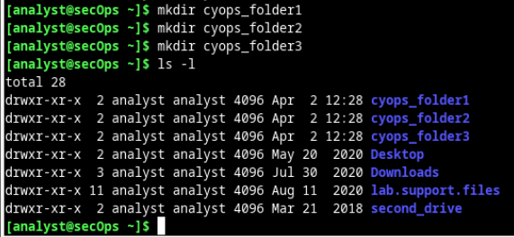

Creating 3 new folders using the **mkdir** command

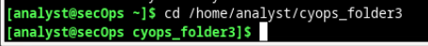

Entering the **cyops_folder3** directory

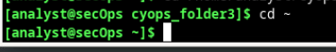

Going back to **/home/analyst** directory

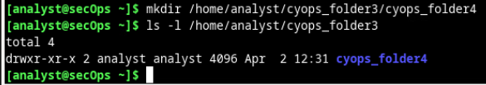

Creating a new folder **cyops_folder4** inside **cyops_folder3**

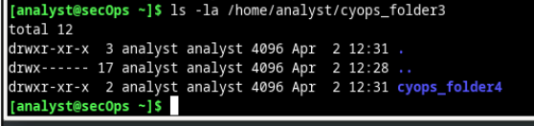

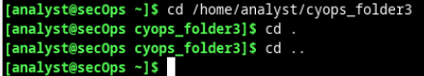

Changing directory to **cyops_folder3**

Using “**cd .**” doesn't switch the directory, but using “**cd ..**” returns you to the parent directory

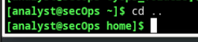

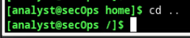

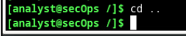

#### Step 4

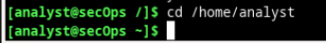

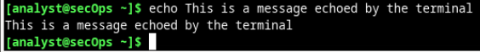

Using **echo** command to return a message in terminal

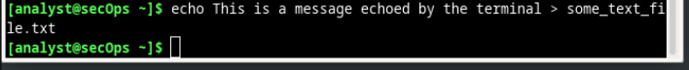

Adding “**> some_text_file.txt**” to the previous line will save the text that was echo’d into a **.txt** file

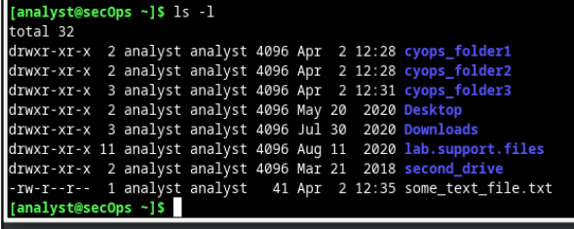

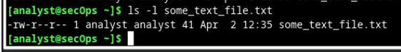

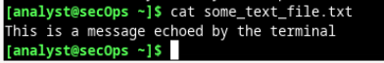

Using **cat** command to return the value of the **.txt** file

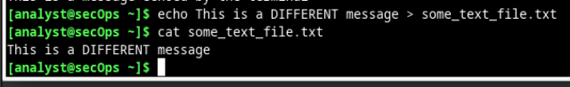

Changing the content of the file using the same command but different message

#### Step 5

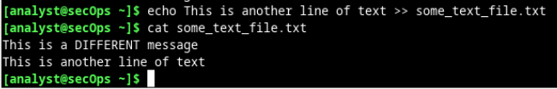

Same command used but instead of using “**>**”, “**>>**” is used – this appends to a current .txt file

#### Step 6

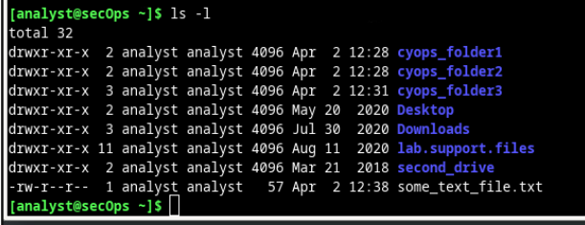

Checking home directory

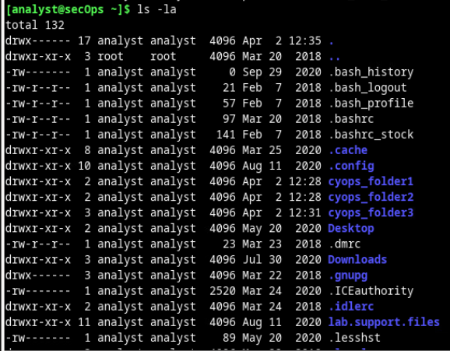

Checking home directory (with hidden files)

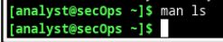

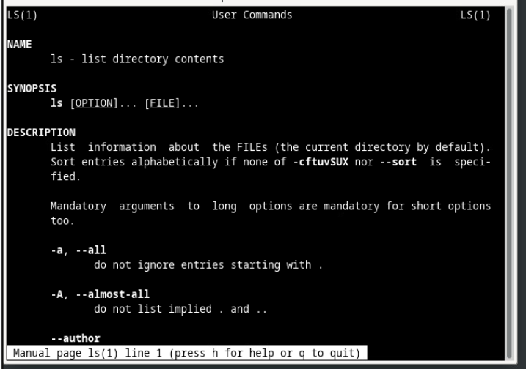

### Part 2

#### Step 1

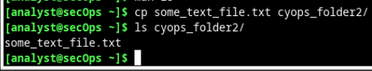

The command **cp | file to copy | directory to paste into**

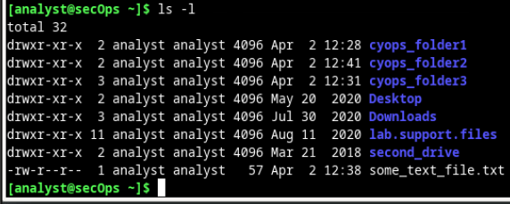

Checking both **home** directory and **cyops_folder2**

#### Step 2

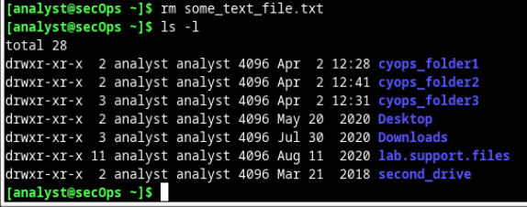

Deleting the **some_text_file.txt** using the **rm** command and checking if the file has been deleted

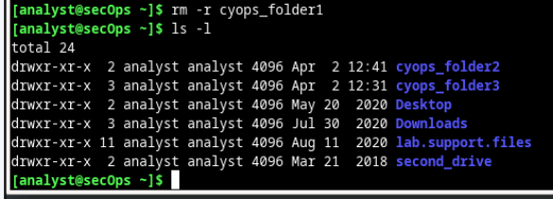

Deleting the folder **cyops_folder1** using the **rm –r** command and checking if it has been deleted

#### Step 3

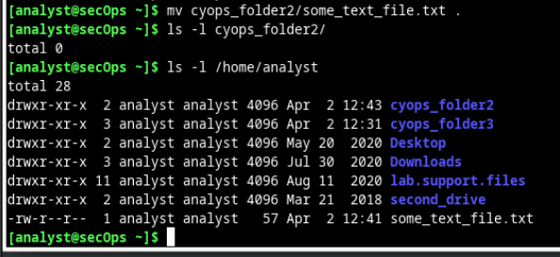

Using the **mv** command followed by the file (with directory) followed by the destination will move the desired file to the location mention (in this case to the **/home/analyst/** directory as that is the directory we are in

## 8.5.4 Lab - Navigating the Linux Filesystem and Permission Settings

### Part 1

#### Step 1



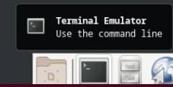

Accessing the VM on netlab and opening terminal

#### Step 2

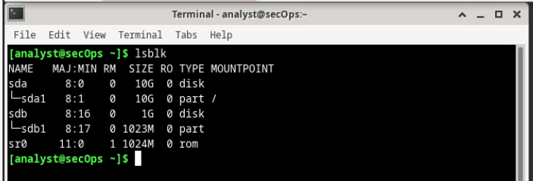

Using the **lsblk** command to check the block devices

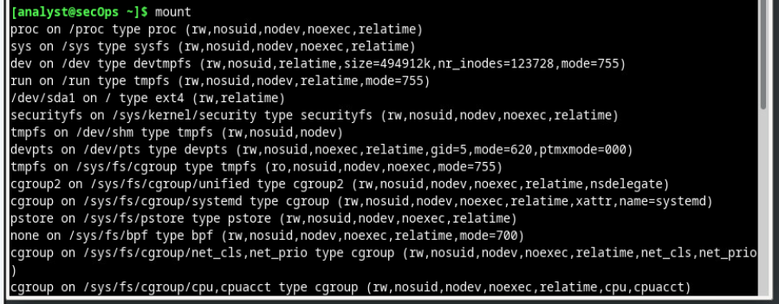

Using the **mount** command to check the currently mounted filesystems

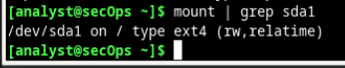

Filtering the output of the **mount** command to the root filesystem

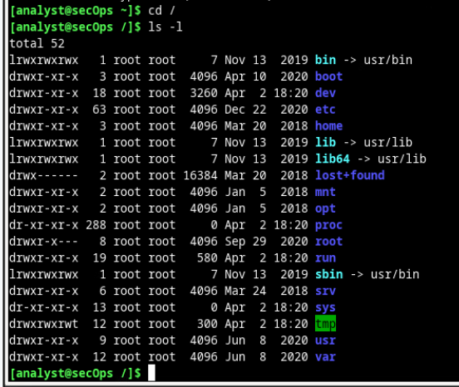

Switching the directory to **/home** and checking the visible files & directories on it

**Sdb1** isn't visible as it isn't mounted

#### Step 3

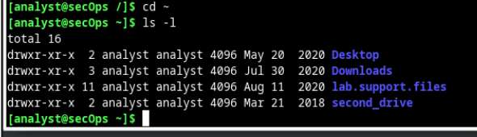

Checking if “**second_drive**” directory is present

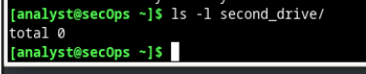

Checking contents of the directory

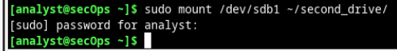

Mounting **sdb1**

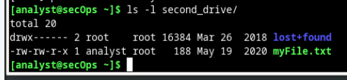

Checking if it has been mounted successfully

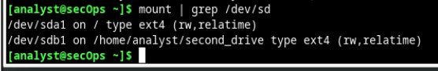

Checking partition details

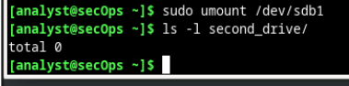

Unmounting **sdb1**

### Part 2

#### Step 1

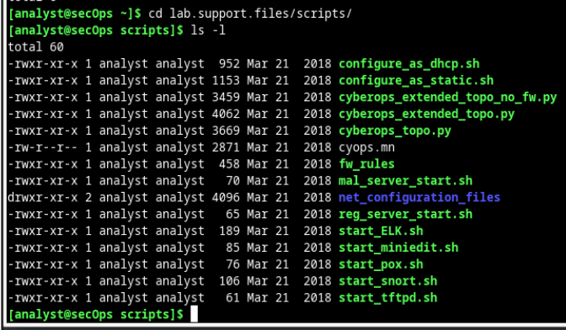

Changing directory to **lab.support.files/scripts** and checking file permissions

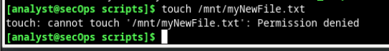

Attempting to use the **touch** command

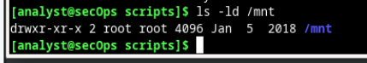

Checking the permissions of parent directory



Changing permissions of a directory using the **chmod** command

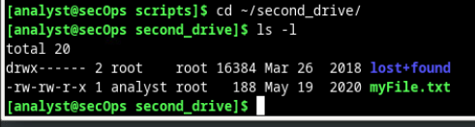

Changing directory to **/~/second_drive**

**myFile.txt** has read and write permission for owner, read permissions for group owner of the file and read permissions for all other users

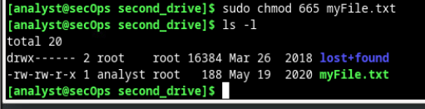

Changing permission of **myFile.txt** so that group owners can read and write

**chmod 777** would give –rwxrwxrwx permissions

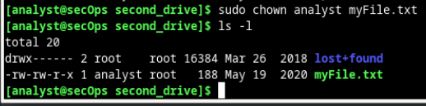

The command **chown** changes ownership of the file

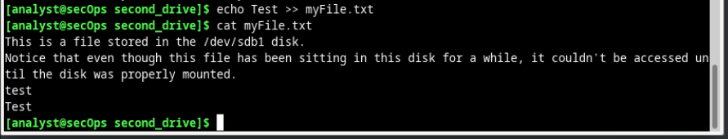

Appendin to the file and the changes have been applied to to permission changes

#### Step 2

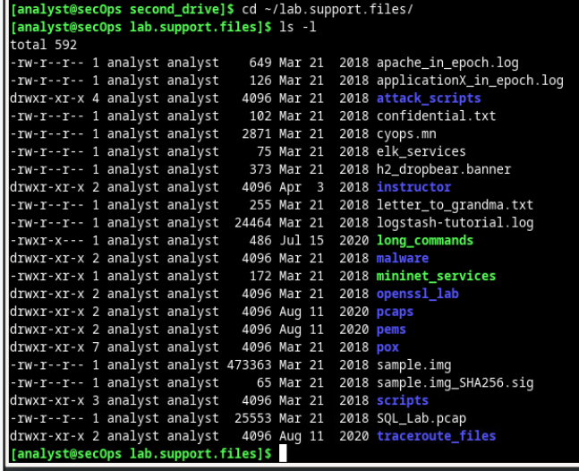

Changing directory and listing all files in the directory

### Part 3

#### Step 1

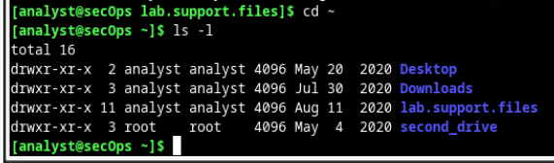

Changing directory to **/home/analyst** and checking files & directories

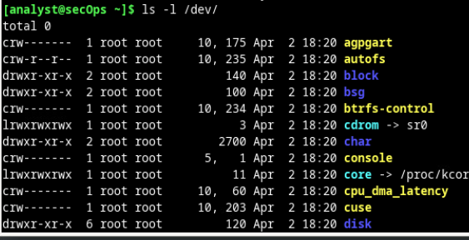

Checking files and directories inside **/dev** directory

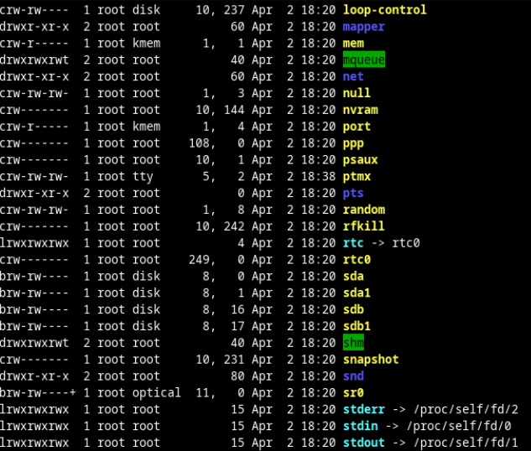

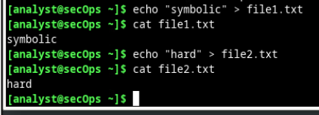

Creating 2 **.txt** files

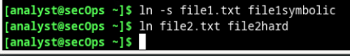

Applying a symbolic link to 1 file and a hard link to the other

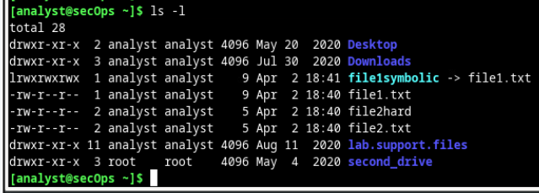

Checking directory to see changes made

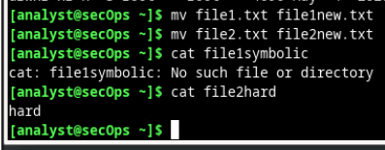

Replacing the names of the files and executing each file to see if the new file names work

# Module 18: Cryptography

## 18.1.11 Lab - Use Classic and Modern Encryption Algorithms

### Part 1

#### Step 1

Opening the lab VM

#### Step 2

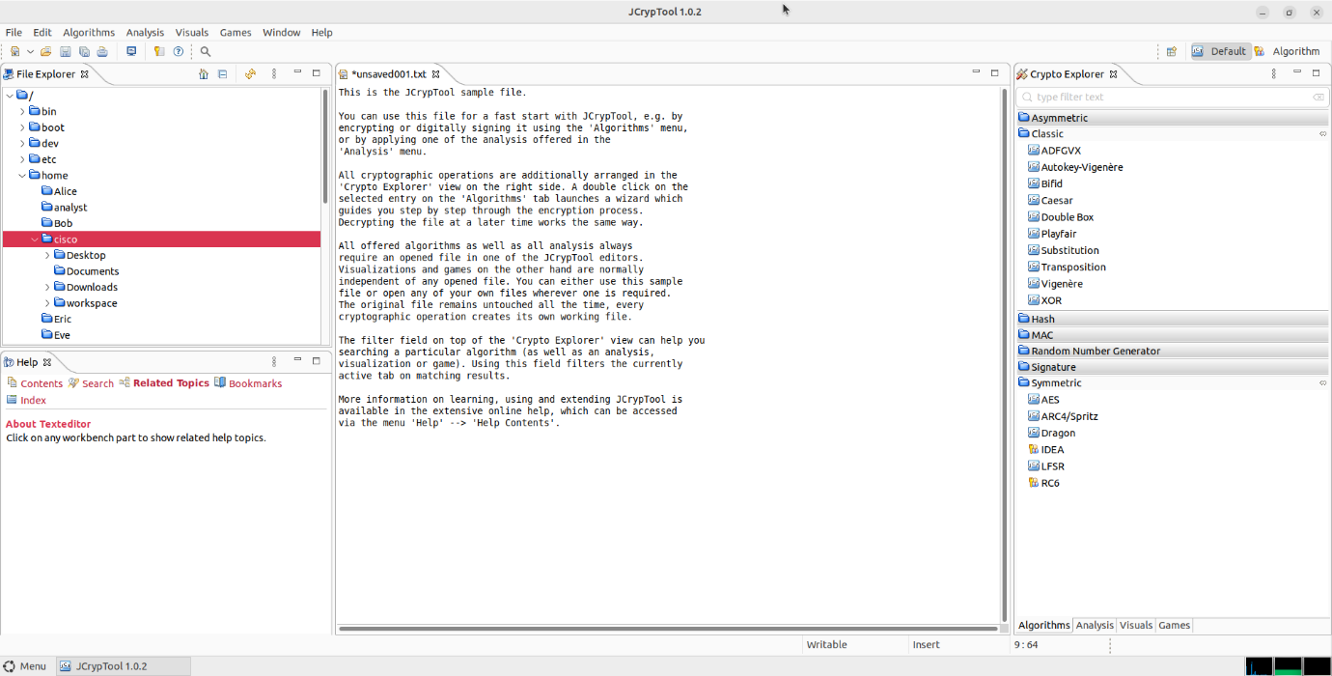

Opening the **JCrypTool**

#### Step 3

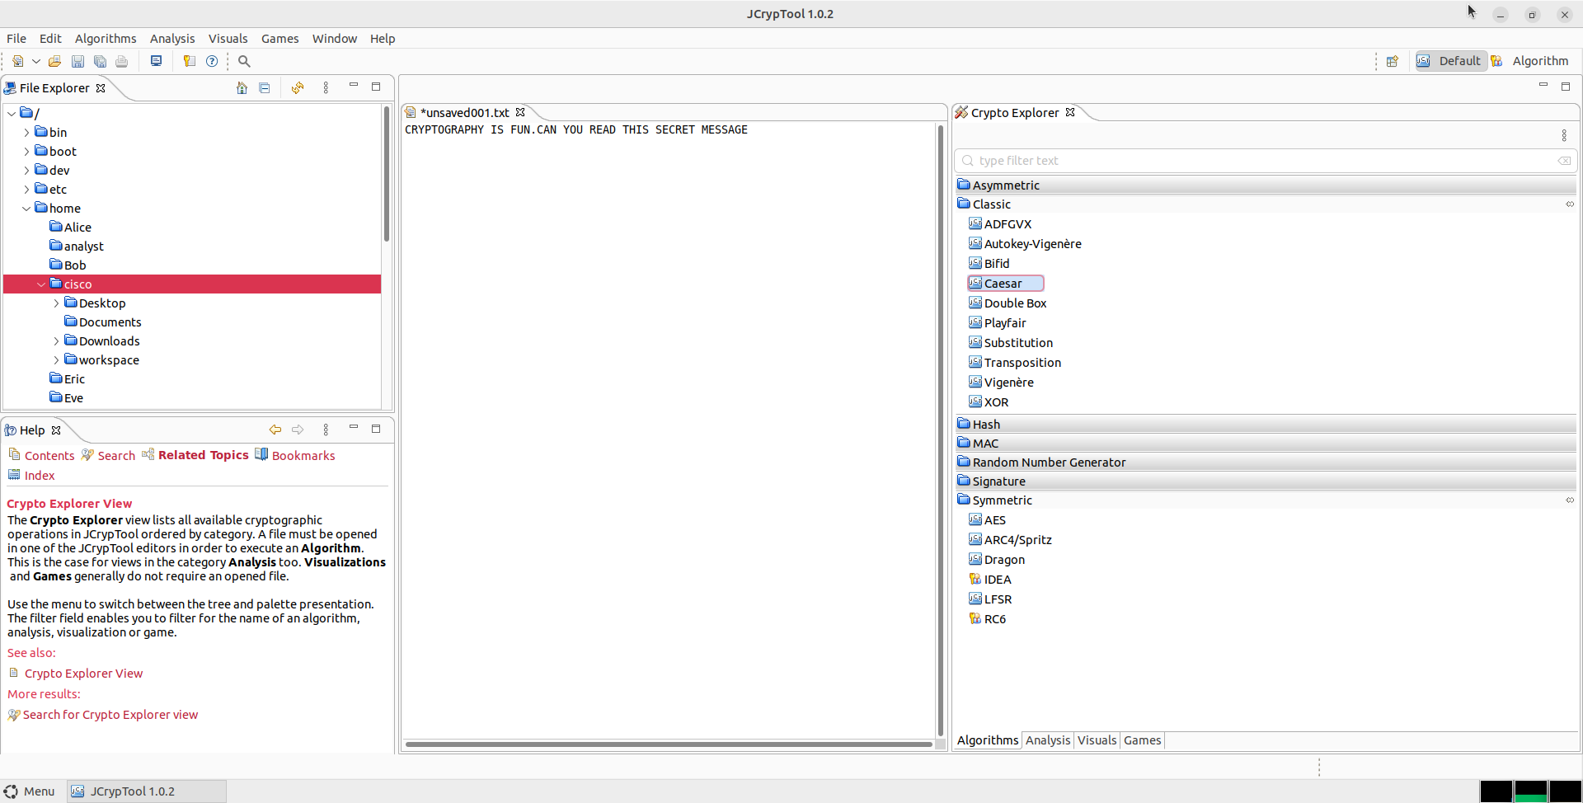

Replacing the message inside **unsaved001.txt**

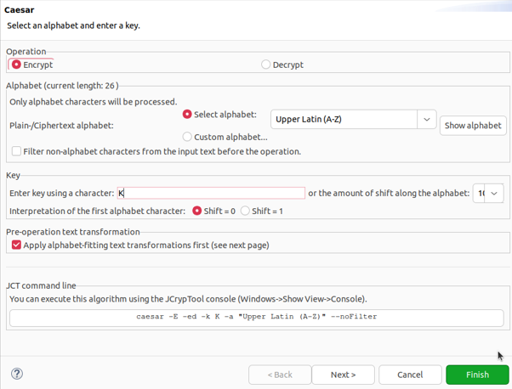

Checking and setting parameters for **Caesar**

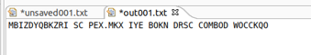

Checking the output on the new **out001.txt** file

#### Step 4

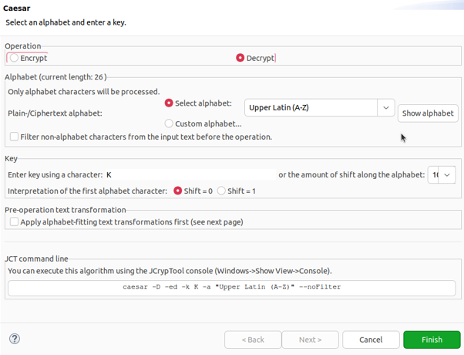

Setting **Caesar** to decrypt the encrypted message

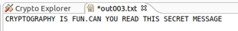

Decrypted message

#### Step 5

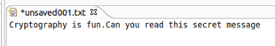

Creating a new file with a new message

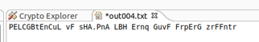

New encrypted message

### Part 2

#### Step 1

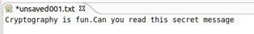

Creating a new file with a new message

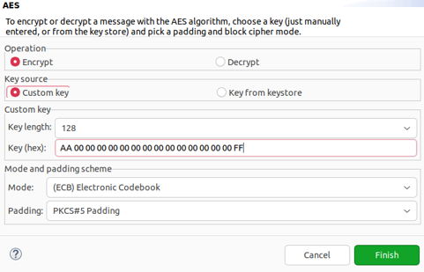

Setting **AES** to encrypt the message

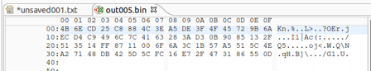

Encrypted message

#### Step 2

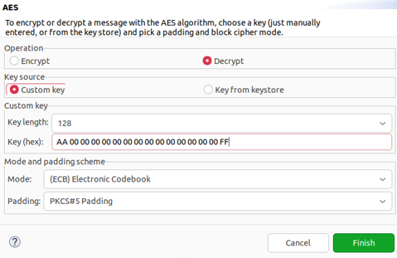

Setting **AES** to decrypt the message

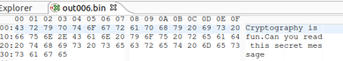

Decrypted message

### Part 3

#### Step 1

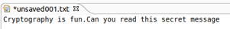

Creating a new file with a new message

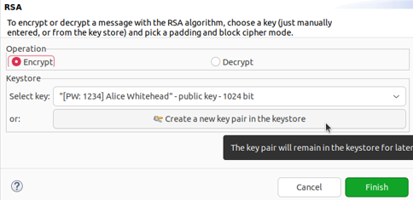

Opening the **RSA** algorithm

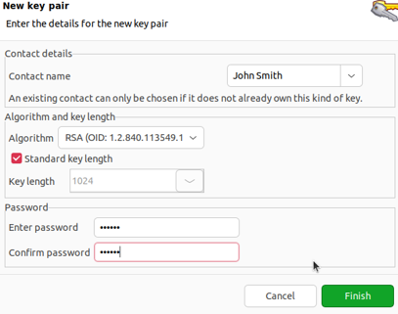

Creating a new **key pair**

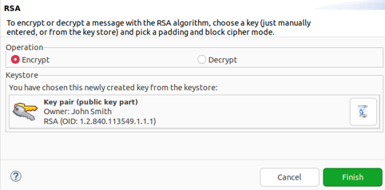

Using the new key pair

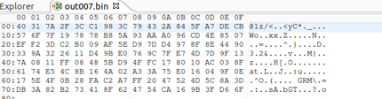

Decrypted message

#### Step 2

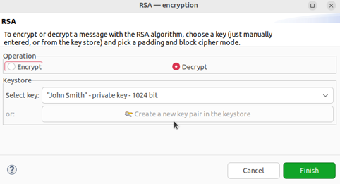

Setting **RSA** to decrypt the message

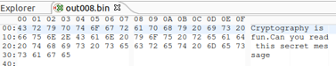

Decrypted message

## 18.4.10 Lab – Hashing Things Out

### Part 1

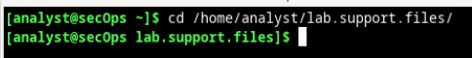

Opening a **terminal** and changing directory to **/lab.support.files**

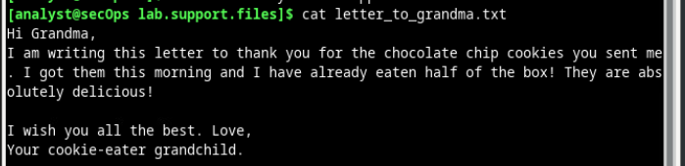

Executing the **.txt** file using the **cat** command to check its contents



Hashing the **.txt** file using the **sha256** algorithm

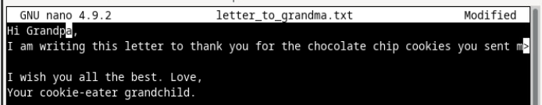

Altering the contents of the **.txt** file using **nano**



Hashing the **.txt** file again using the same algorithm, but this time given a different output



Hashing the **.txt** file again using a bit length of 512 (rather than the previous 256)





Generating the hash of both bit lengths using the **sum** appendix to the **shaXXX** command

The hashes are the same as shown in the previous screenshots as the same hash bit-length has been specified as before (per each bit length)

### Part 2



Using the **cat** command to display the contents of the **.sig** file



Calculating the hash of the **.img** file

The image was downloaded without errors as the has value of the **.img** is the same as the **.sig** file, resulting in a match

## 18.5.5 Lab - Generate and Use a Digital Signature

### Part 1

Opening the lab VM

### Part 2

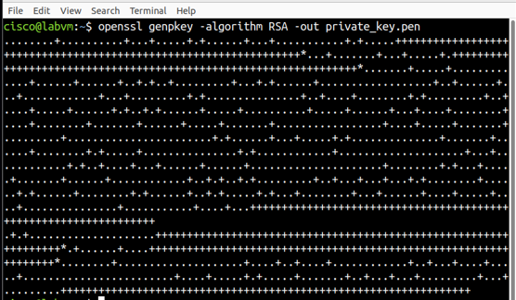

Generating a private key using the **openssl genkey** command alongside the **RSA** algorithm and outputting it into a **private_key.pen** file

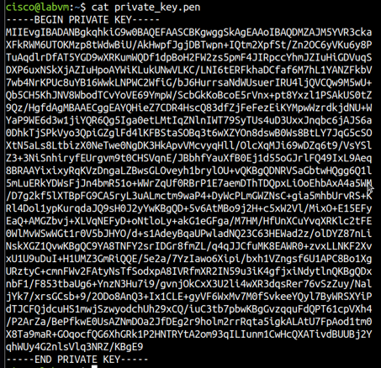

Using the **cat** command to show the contents of the **.pen** file

### Part 3

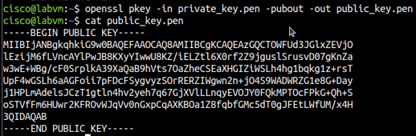

Generating a public key using the **openssl pkey** command, by using the **private_key.pen** file as the input and outputting a new file called **public_key.pen**

This new file is then executed with the **cat** command

### Part 4

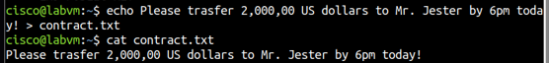

Creating a new **.txt** file and using the **cat** command to check its contents

### Part 5



Creating a signature for the previously created **.txt** file

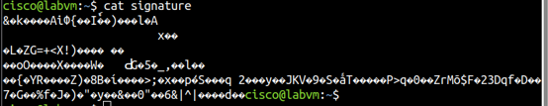

Checking the contents of the signature file using the **cat** command

### Part 6



Checking if the file has not been tampered using the **openssl dgst** command, returning a positive validation

### Part 7



Opening the **.txt** file using the command **gedit**

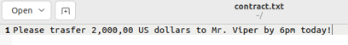

Changing the contents of the file

### Part 8



Rechecking the validity of the file using the **openssl dgst** command, and this time it returns with a verification failure

# Module 19: Technologies and Protocols (ACL)

Please complete the **two** multiple choice quizzes available under **19.1 Monitoring Common Protocols** and **19.2 Security Technologies** and provide a screenshot of your completed experience/defender points shield, e.g.:

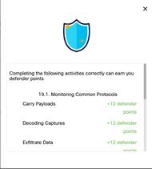

## 19.1.7 Check Your Understanding - Identify the Monitored Protocol

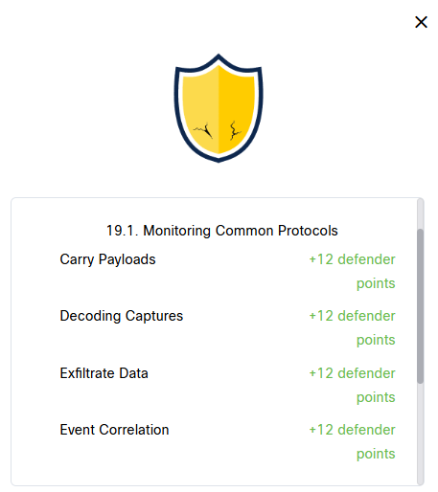

## 19.2.6 Check Your Understanding - Identify the Impact of the Technology on Security and Monitoring

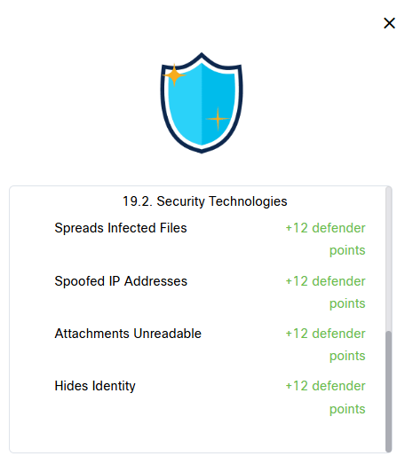

# Reflective Report (cryptography and access control)

Throught completing these allocated labs and content that has been made available on the cisco website, it has helped strengthen my understanding on different security measures that are available to secure devices, and methods that are potentially used in businesses, such as setting up user accounts or limiting access to specific users.

More specifically the usage of Linux and hashing inside of the terminal was one of my key learning points as one of the tasks to complete was verifying a download. This was done by checking the has value of the downloaded file and comparing it to the **.sig** file (signature) hash value – if the hash output was the same then the download was successful, if not then it failed. Another key task that was completed was changing privileges of files and which user / groups can access it, which is displayed by “-r—r—r—” which would give the owner reading privileges, owner groups reading privileges and other users reading privileges – for a file, if it was a directory then it would start with “d” instead of "-“